March 31st, 2022



SimplyPet

Everything you and your pet need in one app

Computing Project 2 - IS52018 (2021-2022)

A web application designed to aggregate the most important features a pet owner will need into one place, to make pet owning simpler.

Brought by 6 passionate, pet-loving students.

**<https://simply-pet.herokuapp.com/>**

Filip Condac - [fcond001@gold.ac.uk](mailto:fcond001@gold.ac.uk), 33684536

Sebastian Farrant - [sfarr002@gold.ac.uk](mailto:sfarr002@gold.ac.uk), 33643814

Edoardo Fiore - [efior001@gold.ac.uk](mailto:efior001@gold.ac.uk), 33655793

Omar Tahir - [otahi001@gold.ac.uk](mailto:otahi001@gold.ac.uk), 33684350

Riann Rahman - [rrahm013@gold.ac.uk](mailto:rrahm013@gold.ac.uk), 33638195

Zofia Kaska - [zkask001@gold.ac.uk](mailto:zkask001@gold.ac.uk), 33672521

# Content

Introduction 4

The Lean Start-Up Method 5

Project Management 7

The Team 7

Methods and style 8

Specification 11

Functional Requirements 11

Non-Functional Requirements 11

System performance and scalability 11

Usability and accessibility 12

Security and reliability 12

Technical Specification 13

Code Style 13

Technical Challenges 13

Pet Passport Page 13

Pet Tracker Page 13

Booking Page 14

Technical Architecture 15

Software Architecture 15

Log In System 16

Pet Passport Storing Data 17

Booking system back-end 17

Pet tracker system back-end 17

Design 18

Overview 18

User Guide 20

Home Page 20

Log-In & Sign-Up Page 21

Pet Tracker 22

Pet Passport 23

Booking Page 24

About Page 25

Contact Us Page 26

End-Product Testing 27

UI + Usability evaluation 28

Testing methods 28

Results 29

Testing methods 31

Results 31

Home Page Analysis 32

Notable Thoughts 32

Pet Passport Page Analysis 33

Notable Thoughts 33

Pet Tracker Page Analysis 34

Notable Thoughts 34

Appointments Page Analysis 35

Notable Thoughts 35

Contact Us Page Analysis 36

Notable Thoughts 36

Conclusion 36

Functionality Evaluation 37

Error handling 37

Test driven development and unit testing 37

Evaluation Plan 39

User evaluation involving representative stakeholders 39

1. Pet owners 40

2. Veterinary Practices 40

3. Developers 40

4. Sponsors 41

Evaluation 41

Future Work 41

Ethical Audit 43

Conclusion 44

Bibliography 45

Appendices 49

1) Meeting Log 49

2) Online Resources used during the project 53

# Introduction

The second half of this project, and subsequently this report, is the product of our team utilising market research and knowledge we obtained when developing our project proposal to bring our idea to life. We have developed and outlined our software’s value proposition and key functions in accordance with our market research and competitor analysis through the means of research backed by data (*appendix* 2.8), surveying, designing, and prototyping that was conducted in the proposal phase of our project.

Our initial M.V.P. (Moogk et. al, 2012), includes software functions such as the ability to schedule veterinary appointments, aforementioned ‘Pet Passports’, and a pet tracking service. Drawing back to our critical evaluation and evaluation plan conducted at the end of our project proposal report, we are placing a great emphasis on the streamlined simplicity and ease of use of our software application - abstracting anything that is not of direct use to our potential users, ensuring the product was easy on the eye and simple to navigate. This was one of the underlying key concepts discovered when researching and analysing other successful services operating in a similar field to ours. Using our earlier prototypes and subsequently the insight they gave us, we know our software has to look *professional, sharp and clean*. We have identified the most applicable colour and design schemes for our application, taking inspiration and incorporating elements from successful competitors.

# The Lean Start-Up Method

Referencing the double diamond approach (Rugman et. al, 1993), to product development and design, we have now completed our initial research stage, the diverging process, where we discovered insight into our problems and the many ways they could be solved. Subsequently, in our research converging process we refined our potential solutions and narrowed our scope into an idea of what our product needed to be. We are now converging our ideas and research conducted in our project proposal into a tangible product and working solution. This report is a comprehensive documentation of our development process following on from our design and research phase. We will be outlining our project management, development specification, coding styles and exhaustive testing techniques as well as any relevant technicalities and challenges we face along the way. A complete evaluation is present at the end of this report critiquing our subsequent work and examining any challenges we faced. We have also reflected on how we could refine our development process for any projects we decide to undertake in the future.

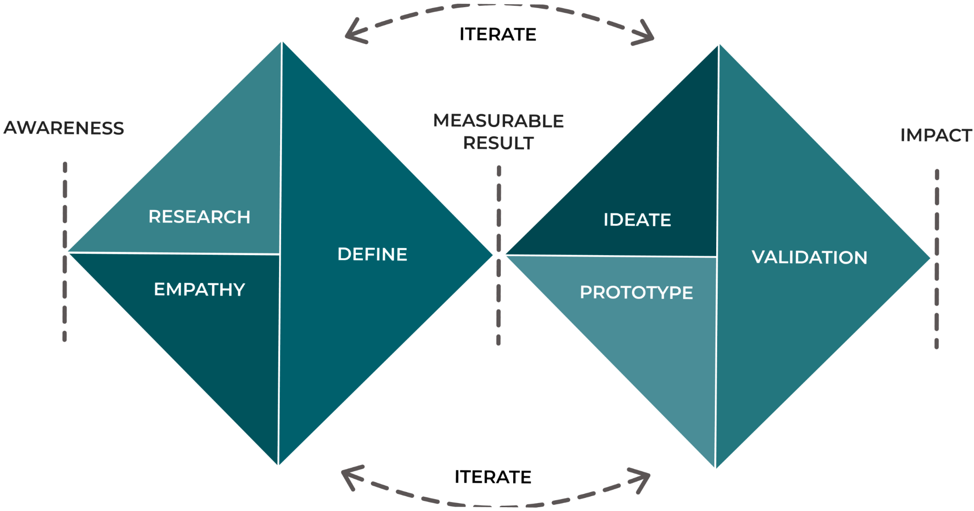

*Double Diamond Approach (appendix 2.5)*

Using the Lean Start-up Methodology, the platform’s objective will be to create a minimal viable product, which will avoid creating products that users may reject nor require, allowing developers to collect the most amount of verified learning with the least amount of work while providing a high-quality result (Duc et. al, 2016; Ries, 2011). Creating a clear MVP, measuring, and learning will be essential, as will actionable data that indicates the cause-and-effect question (ibid). To attract early investment, Simply Pet will focus only on the booking system, pet tracker and pet passport (Blank, 2013), while the final goal will be a multi-featured pet services aggregator. To develop a solid and durable MVP, the strengths, weaknesses, opportunities, and threats analysis is an essential tool and will help measure the potential benefit and cost trade-offs (Sabbaghi et. al, 2004). When we look at the SimplyPet’s SWOT analysis diagram designed with Venngage (*appendix* 2.6), we can see that it has potential, but also many challenges ahead, such as maintaining a high degree of accessibility and inclusion after the product is deployed. The platform is particularly vulnerable to imitation and substitution, which, when paired with a high barrier to entry imposed by the significant financial investment required to establish it, might lead to increased competition if imitators or replacements gain momentum (Porter, 1989).

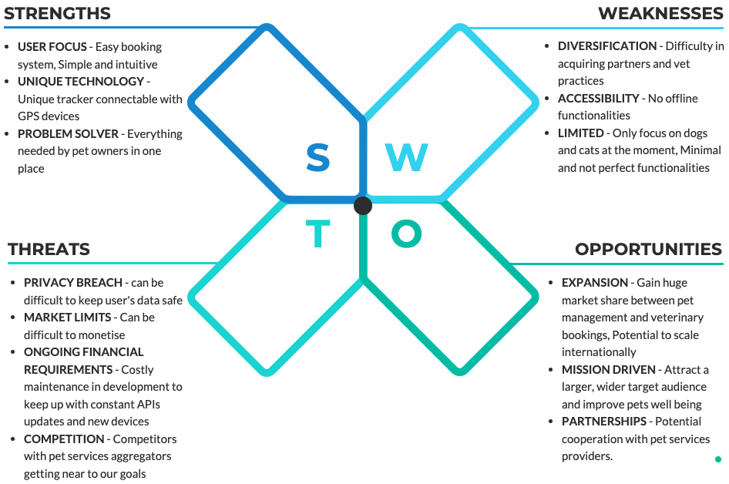

# Project Management

## The Team

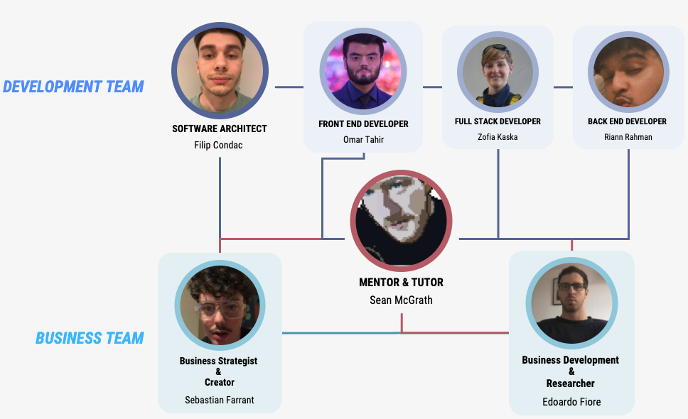

*The Team (appendix 2.13)*

Fortunately, the evaluation of our technical architecture from our project proposal showed what we planned to use will work best for our team, allowing us to work in such a way that we can all be efficiently engaged in all areas of the project. Each team member will be able to utilise their skillset to the highest degree, encouraging the highest level of productivity. We did initially consider utilising more complex options and processes but did not want to take the risk of being unable to complete the project or having to backtrack on ourselves to find an easier alternative.

As the project became more technical, we decided to proactively section the team in two smaller groups. Sebastian and Ed would focus on the report using Google Doc (*appendix* 2.15) and subsequently formatting it on a Word document (*appendix* 2.16). Would then carry on with the testing, and the business side of things, as their university programmes are more entrepreneurship/business focused.

On the other hand, Filip, Zofia, Omar and Riann would work on the development of the application, with Filip assigned as the team leader given his extensive knowledge in this field. Although the team was split in two mini-teams, collaboration, and communication across the two teams has been necessary to keep pivoting and re-iterating as the steps progressed. On the two weekly meetings the development team would present to the business team the progress done, share the contents, whilst the business team would present the progress made on the report and on the testing. Each team then carried on, on their specific tasks as a group and individual tasks, always reporting the progress on the Gantt diagram and meeting log.

## Methods and style

Following the presentation and design of the application, we kept working as a team slightly differently than we did in the first part of the project. Meetings took place twice a week in person and on Teams (*appendix* 2.14), and after every lecture with Sean we would then meet up and reiterate based on his feedback.

We kept using Trello (*appendix* 2.9) as a project management tool (see board below).

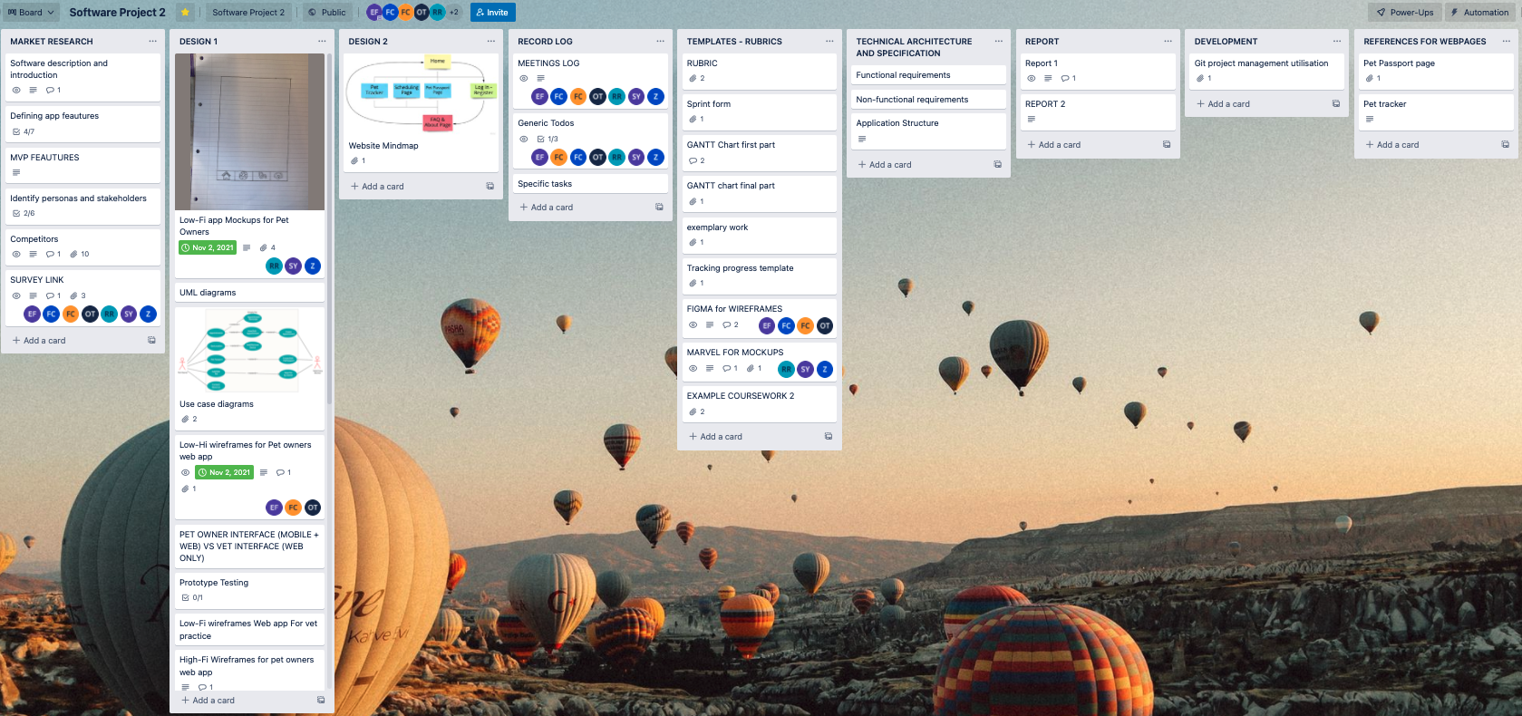

<https://trello.com/b/J4FkiPZ2/software-project-2>

We added any applicable research or knowledge discovered to Trello, in line with the progress made with the testing phase. We also shared links to various documents stored in the cloud such as Gantt Chart, Final Report, Surveys, and other spreadsheets we used to monitor the testing phases of the project to Trello. Trello also allowed us, along with the meeting log (*appendix*.1), to assign tasks to each of us and track, monitor and assess the outcomes collectively on each weekly meeting.

One of the fundamental project management methods we are incorporating during this phase of the project is using Git (see below gif going through the steps for pulling and committing changes). The development team adds and implements their contribution from their personal devices, through Visual Studio (*appendix* 2.12). They send requests to the GitHub project, and then one of the other team members amends and approves the contributions.

This allowed the development team to work collaboratively on the project, still doing their own parts of code and general parts of the project to GitHub (*appendix* 2.10).

This allows everyone to see each other's code and subsequent updates to certain areas of the software in real time, letting us continuously monitor and evaluate its development.

The project on GitHub was split into multiple branches dedicated to individual pages of the software application. This separation reduces error severity as they were unable to affect the project as a whole; errors are limited to the branch they were caused in. Once the project had finalised these branches then merged into a whole functional project.

We scheduled two weekly meetings as a team, Monday at 12pm and Wednesday at 9am. The business team meets once more per week to work together and motor the progress of the testing and report. During these meetings we discuss and assess what progress we have made throughout the week, as well as bring up any potential difficulties we are facing, collecting feedback, and seeking help from each other when needed.

A record log, shown at the end of this report (*appendix* 1), keeps tabs on these meetings and thus allows us to track our progress and make sure we are staying on course in respect of our timeframe. This record log also ensures each member is kept in the loop irrespective if they are unable to attend one of the meetings.

A Gantt chart (Kumar, 2005) was also used across the period for the project to monitor and track personal and group tasks. See snapshot below, taken on March 8th.

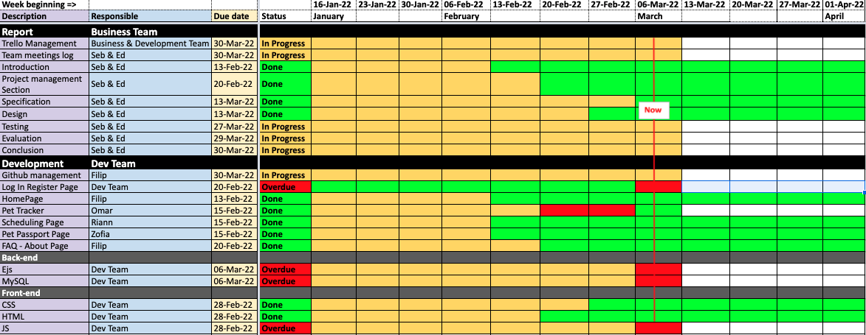

*Gantt chart used during the project development*

# Specification

## Functional Requirements

Functional requirements are product attributes and properties that are required for users to accomplish their tasks and for the system to perform as intended.

Our functional requirements remain unchanged for the most part from our design phase. We have outlined that the system must be able to register user accounts and those users must be able to log into those accounts that they have created. The passwords entered in by the users when logging in and registering must be hashed and stored securely in the database. The system must check new login details against existing details in the database to ensure no duplicate emails and usernames are created, and instead ask the user(s) to sign up using a different username or email. The system must allow users to register with supported Veterinary practices on the software, enabling them to schedule and book appointments as well as to cancel them. The software allows users to create ‘Pet Passports’ where they can create, store, edit and access information about their pet(s). This information should also be able to be shared to their registered veterinary practice. The users should be able to track their pets on the system by connecting a compatible third-party tracking device. The software should work across all mainstream operating systems and should be supported on all mainstream browsers. It should not require any exceptional computing power with regards to CPU and GPU standards. The application is lightweight and should have minimal latency running on commercial internet speeds.

## Non-Functional Requirements

### System performance and scalability

(Nielsen, 1993) Outlined three primary metrics for response time for webpage loading. For loading times of 0.1 seconds and below, the user feels as if the software is reacting instantaneously. For loading times of around a second, the user will notice a delay but not experience any interrupted thought patterns. Loading times of ten seconds or more will result in the loss of the user's attention. Following these guidelines and expectations for web application performance, the software should start up within 5 seconds of loading. Running on a stable internet connection, the software should also incur minimal latency in the range of <2 seconds when traversing between different pages on the site. This is not considering loading and response times from third party software on our web application, which has been used for the geo tracking feature. The software should be able to perform within these ranges +-20% when operating at perceived maximum capacity.

### Usability and accessibility

There is an appropriate use of metadata on the web application, specifically the use of alt tags describing any images that are present on the site. There is a high polarity between relevant foreground information and elements existing in the background to make relevant text and objects easy to read and interpret. Information text is displayed clearly and concisely to adhere to an accessible reading level thus providing a high level of learnability. The interface’s layout is also consistent when traversing different pages to ensure a proficient level of memorability for users interacting with the software. Appropriate error handling has been put in place to ensure continued and streamlined usability of the application regardless of erroneous action.

### Security and reliability

Passwords generated and entered the software will be subsequently hashed and stored securely on the database which prohibits unauthorised access. The application ensures no duplicated details can be entered into the database by running a check every time a user signs up thus ensuring protection of sensitive information from other users. The password is never displayed publicly and hidden from the users throughout the web application. The pet tracking data will also be stored securely and not accessible to anyone but the relevant users and third-party handlers.

# Technical Specification

## Code Style

The development team had some meetings before beginning where some standards and coding guidelines were defined. Code has always been indented according to the general coding indentation rules for comprehensibility (Mara et. al, 1983), same went for comments all cross to make it easy to read and understand even if you were not involved on that task would allow you to understand it (McConnell, 2004).

We generated a template HTML that has the header, footer, and all semantic tags and has been passed on to all website pages.

When building the programme, accessibility was also considered, with high semantic tags and alt text for images. Except for several internal inline CSS needed for some special conditions, CSS has been kept mostly external to enable tracking and editing of the programme.

Even in the early prototypes, we employed CSS tags like REM to make the website as responsive as possible. Gifs showing page responsiveness are included in the design section.

## Technical Challenges

### Pet Passport Page

Some of the problems we had with the initial pet passport page design were primarily with the ID card organisation and layout. The key goal was to keep the pages both accessible but also design orientated to enhance user experience. The ID cards needed to shrink according to the page size in a way that protects their specific shape and layout, while also organising them into appropriate columns relative to window size. We subsequently ran into a greater problem with the page, which forced us to redesign it. This was due to EJS's lack of support for dynamic client-side rendering, which meant that the page body content could not dynamically alter based on the pet picked using the ID cards. Before the database was connected, this was accomplished via JavaScript functions. As a result, we had to alter the page to include a linear design with a tabular structure.

### Pet Tracker Page

During this section of programming, we faced several challenges, including ensuring that the pet tracker tracks the device's location rather than simply pinning a random location on the map. Tutorials assisted us in overcoming this obstacle, and we were able to write the code that would provide the exact location of the device in real time. Another challenge we faced was ensuring that the map is clear and large enough for the user to navigate.

### Booking Page

One of the things we struggled with when coding the Appointments page was creating a clickable dropdown menu. This drop-down menu was required because it would have been utilised to assist clients in navigating the website by prompting them to pick an option for the queries that asked them what difficulty their pet was having.

The expected conclusion was to question the user: "What appears to be the issue with your pet?" via a form, and then to click on the drop-down menu to show alternatives such as "Eye difficulties," "Fleas," and "Vomiting," among many others.

Setting up the structure and styling/layout of the drop-down menu using HTML and CSS wasn't difficult at first, but the issue emerged when we realised the drop-down menu wasn't as functional as I wanted it to be. This was attributable to the following factors:

1.We only wanted the drop-down menu to appear if the user selected one of the options from the drop-down menu.

2. If the user clicked outside of the "drop down menu parameter," we wanted the dropdown menu to shut.

To solve both issues, we rapidly realised that JavaScript would be required to implement my ideas. To solve problem number one, we used a JavaScript method to toggle between concealing and exposing the content of the drop-down menu. This was accomplished by renaming the element and setting the toggle to "display." This was a little trickier, but it involved adding an if statement to the file that stated that if the "selection" arrow detected that it was hovering around the drop down menu button, it would then enter the next if statement, which stated that if it detected a click within the length of the drop down menu button, it would show the options, and otherwise it would hide them.When it came to creating the Date and Time selecting capabilities, a lot of thought went into figuring out what JavaScript knowledge was necessary. This entailed a great deal of study on sites like Udemy, YouTube, and Google. Understanding how to combine all the parts to develop a working functionality for booking appointments was critical.

# Technical Architecture

## Software Architecture

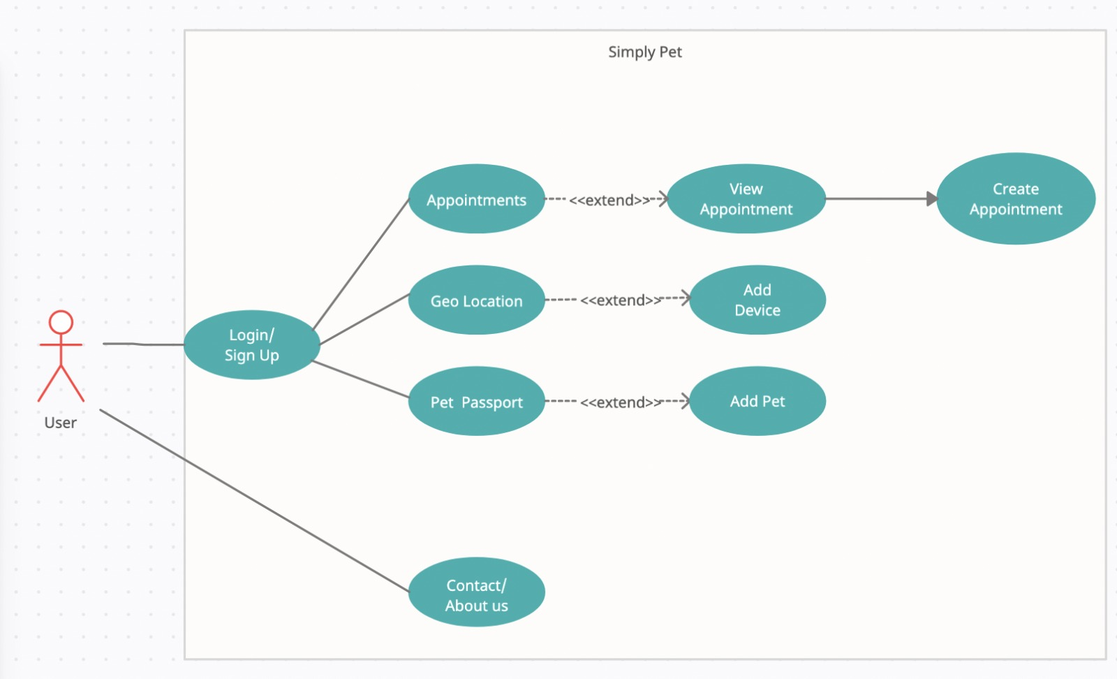

*UML diagram*

The front-end of our software application will be displayed using HTML with its core functionalities handled by JavaScript and CSS. We are also making use of Bootstrap, an open-source JavaScript and CSS library and framework as it has many useful built-in design features and functions that will aid and streamline our development process enabling quick, responsive programming (Gaikwad et. al, 2019).

The reasons why we have decided to adopt this specific framework is speed of development as it is one of the most significant advantages of adopting Bootstrap. It also has a large support community behind it, so we were able to find assistance when needed. Furthermore, Bootstrap is always being updated, and the designers have done an excellent job in constantly releasing new versions and great updates.

The back-end of our software application will be handled by EJS, Express-Sessions, Express and Node.JS using the resources we had access to (*appendix* 2.26,27,28,29), since Node.JS Node.js is easily used as a server-side proxy, allowing it to manage a huge number of simultaneous connections while being non-blocking. It's particularly handy for proxying various services with varying response times or gathering data from many sources (Tilkov et. al, 2010). Node.JS will assist handling our inputs and outputs and any event driven server-side obstacles. We require Express’s ability to handle requests as not every user will be requesting the same data.

We use Google Cloud SQL (*appendix* 2.11) for the database, a database service managed and owned by Google Inc, and very versatile as all applications hosted on Google Compute Engine, Google App Engine apps, and external applications and users outside of the Google Cloud Platform can access MySQL databases stored on Cloud SQL. Moreover, it is reliable, quick, and free (Krishnan et. al, 2015). We will be using a simple MySQL database running on our server which will be displayed on the front-end using EJS and Express. This will make the process of transmitting and storing data much less troublesome.

The login system will function through an express session and cookies. Once the login has been accepted the session begins. This means we can have differing sessions, thus allowing multiple users to interact with the system simultaneously. There is a routing system, created through express that handles the requests and results. Once the user is logged in the web applications pages are rendered (App, Pet tracker and Pet Passport). This in turn switches the login status to true. A false status redirects users to the login page.

Users sign up by entering in an email, username, and password. A post method is then used to grab these details and check for any potential matches against emails and usernames already registered in the database to avoid any duplicate entries. If a match is found the database handles the error by denying it and asking the user to try again. 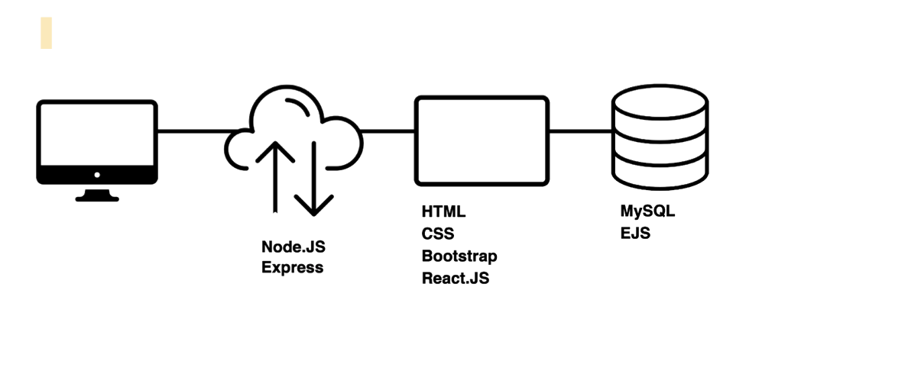

### Log In System

The express session, working mainly with “if” statements, employs cookies, and after the login is approved, the session begins; this allows us to have many sessions if multiple users use the system at the same time. We have created a routing system using express to manage requests and outcomes; after the user is logged in, the three pages (app, pet tracker, passport) are rendered, and the login status is changed to true. We utilise a post method to sign up, which gets the user's email username and password, then validates if the user exists by reviewing emails and eliminating duplicate entries. If the email address already exists, the database handles the problem, refuses the request, and redirects the user to the main sign-up page.

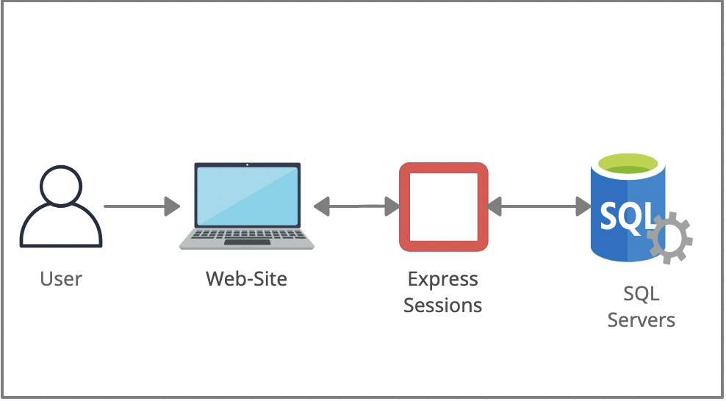

Because our database is remote, we can't utilise async functions because the latency between database requests and server responses will cause it to crash. As a result, we employ promises to inform the application to wait for a response before proceeding. If the email is new (valid input from the user), the promise produces a result that creates a user by inserting the data into the database and saving the email username and password. If the data is invalid, we will reject it. We check for existing database entries with email and passwords by establishing a promise that searches the database and returns true if the user exists, then signs them in and establishes a logged in session. Also stores the session email to the database's associated email, saving the session and any modifications made by the user in his profile/session.

### Pet Passport back-end

The back end of this page is quite simple and straight forward. We have our main page which initially when a new user logs in it will be empty as they haven’t added any pets to their account. This will display a table with empty fields. The function getPet pulls all results based on the sessions email.

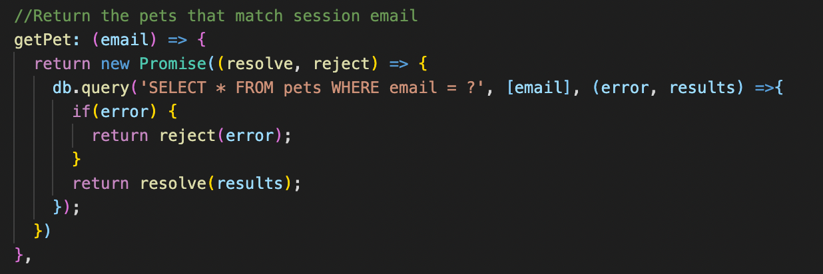

The object with the results gets passed in through the get method while loading the page.

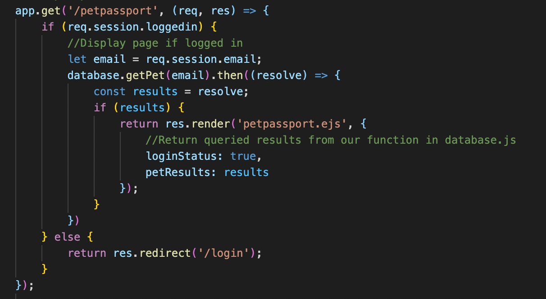

The results are then looped through and displayed in a bootstrap table which generates based on the results.

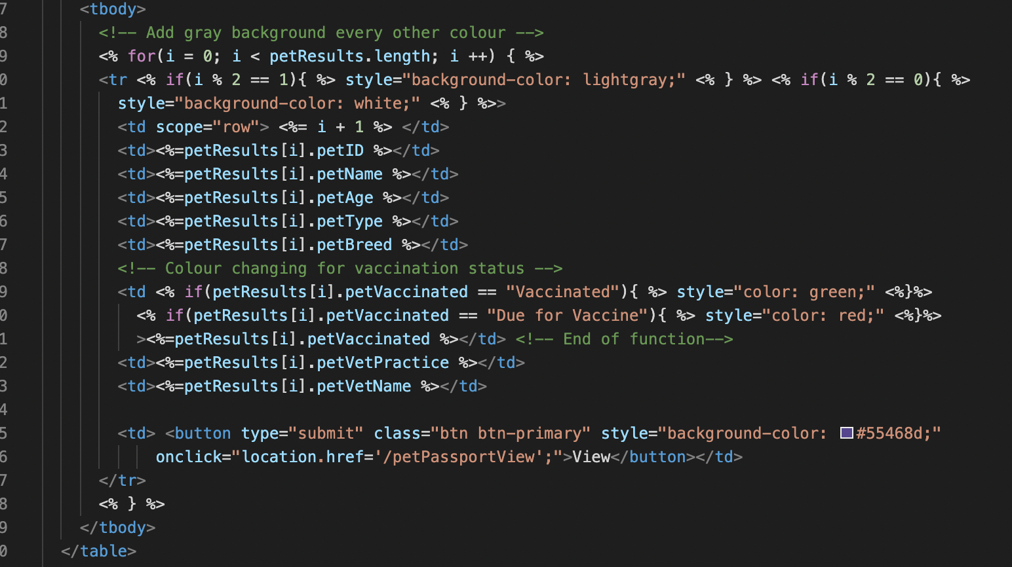

This is the generated table from the code above:

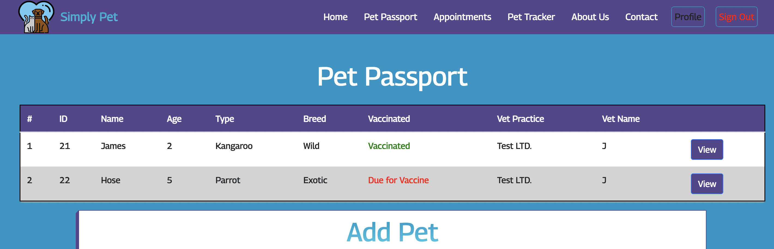

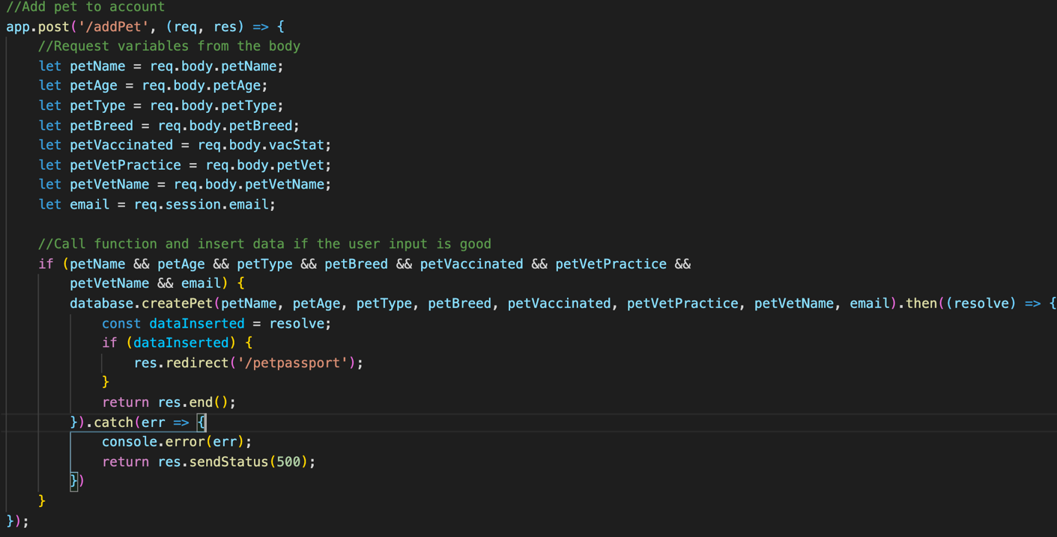The form below is used to add pets to the table by first requesting the information the user put in from the body in a post function. After the required information has been filled in the database function ‘createPet’ gets called.

This function works by creating a promise which sends back a resolve, or a reject based on its success of the query. If we get a true, our query has been successful, and the information has been inserted and the user gets redirected to the pet passport page and the response ends displaying a new pet on display in the table.

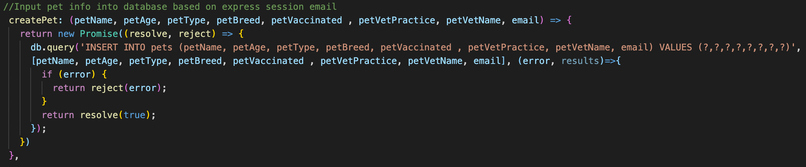

Errors:

If the user inputs a invalid input, the query will throw an error and return the user back to the page. The error is then logged in the console with a status of 500 which is failed query

### Booking system back-end

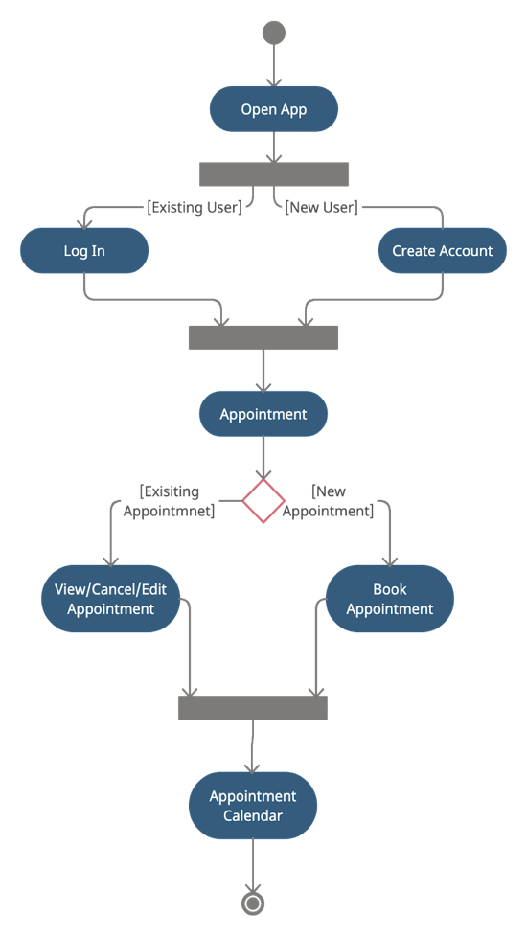

The appointments back end is comparable to the pet passport in that it has a similar structure and displays pet appointments using the same table structure. Similarly, this information is generated by looping through the results returned by the getAppointmnets method, which is a DB query within a promise that returns our information based on the session email.

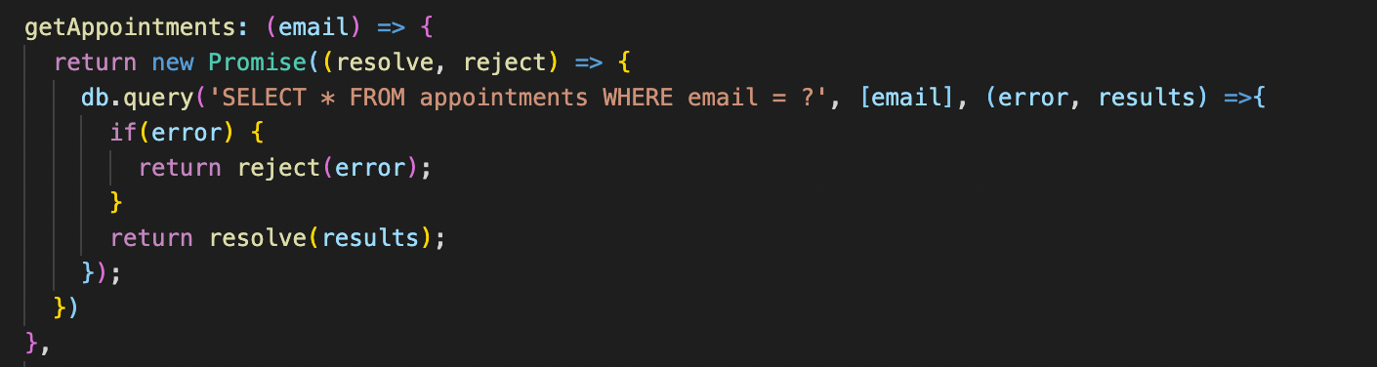

The results are similarly provided into an object, which is subsequently looped into the table. Bootstrap made this process a lot easier by providing easily scalable table formats, and it saved us a lot of time compared to designing our own.

Create Appointment

We use a similar structure to the pet passport to establish the appointment, with the exception that we use a calendar to set the time and day, which has no influence on the back end and is entirely design focused. Similarly, we request information from the body and record it in our appointment book. We use comparable procedures for most back-end jobs, and while they are monotonous, they get the job done. It was a difficulty in and of itself to figure out how to make these requests work and display our content

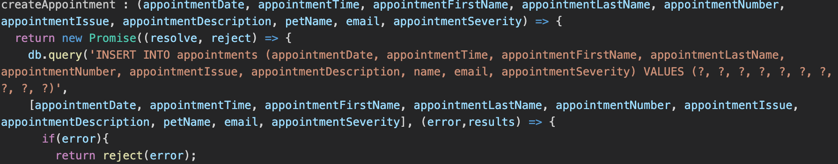

The information was stored in our SQL database table which looks like this.

### Pet tracker system back-end

Google API maps can be used for multiple purposes such as pinpointing a location, calculating distance between two points etc. However, in our case we are using it to calculate the current geo location of the user's pet so they can track them. To Implement google maps API you need to access google developers (*appendix* 2.1) and access the java code which allows you to use Google Maps on your HTML code. Afterwards for your map to work you need to access Google Maps platform to generate a specific API key Which will allow you access to Google Maps. The tracking page has been made amazingly simple for the user so they can easily understand how to use it. They must enter the microchip number of their pet into the search bar and that will help them to track their pets in real time. To track the user’s location most of the help was taken from this video on YouTube (*appendix* 2.2). This tutorial was straight forward and helped us understand how to use tracking on Google maps and without any issues we were able to implement this code into our HTML and got the tracking function working.

# Design

## Overview

We created low, medium, and high-resolution wireframes throughout the initial phase of the project. We tweaked the look of the pages after some revisions and consultation with designers. We also veered off course to create a single online application with extremely responsive behaviour that could be used on both PCs, tablets, and smartphones.

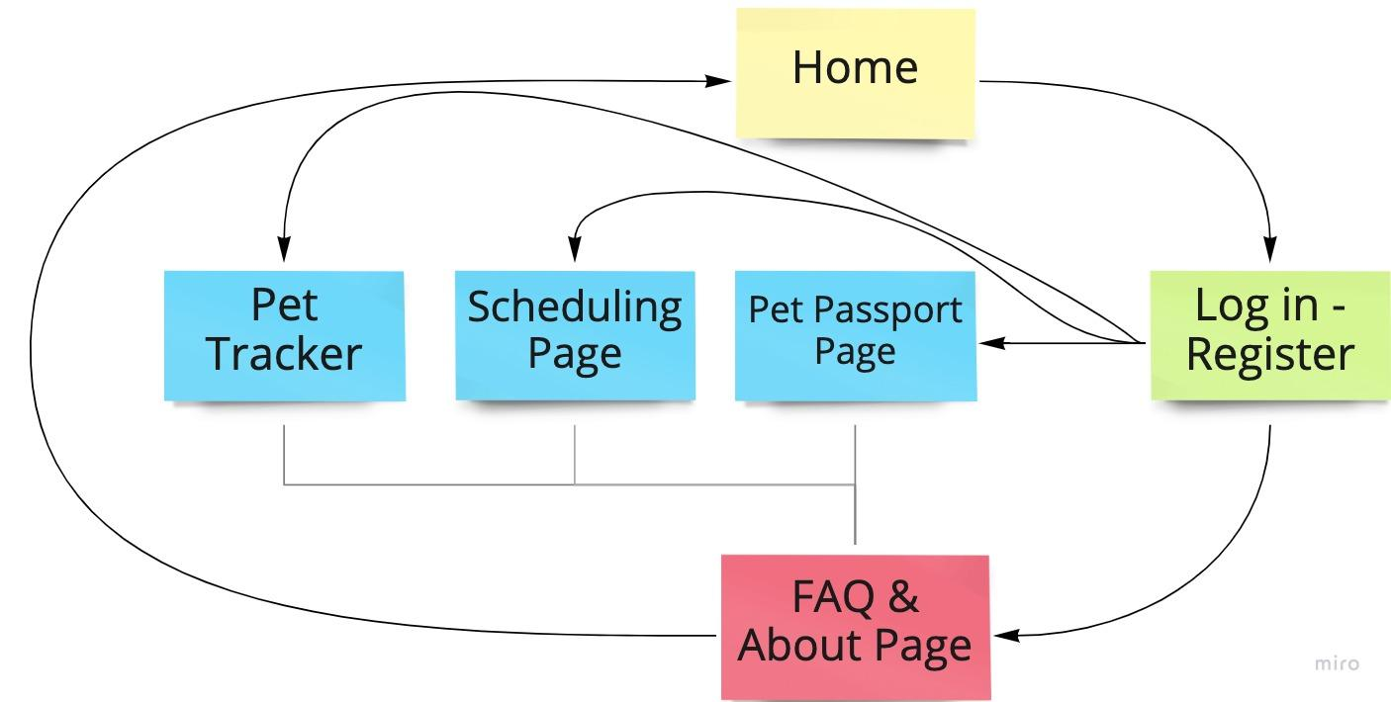We began by building a website mind map with Miro to help the development team understand how the pages will be connected logically and graphically.

*Website Mind Map (Appendix 2.7)*

Users will first arrive at the homepage, where they will find the three main features of the web application (pet tracker, appointment scheduling, and pet passport), as well as the ability to log in or register, as well as a help page with information about ourselves and some frequently asked questions. Each page inside the home page, the login/register area, and the about part is connected to make it easy to travel back and forth.

The entire website was built with the goal of being as accessible and responsive as feasible. For accessibility, we employed semantic tags, metadata and alt images across the html template that was used by all pages (Gardner, 2011). Another important consideration was responsiveness, therefore we used bootstrap and rem measures in the external CSS code for pictures and boxes (ibid). After conducting research and testing the pages with colour blind potential users, the colour palette and fonts were chosen (Karreman et. al, 2007). Since the beginning, accessibility and responsiveness have been top concerns. Let's now delve into each scenario's individual pages.



*Home page Responsiveness*



*Pet passport page responsiveness*

## User Guide

A user guide would be a useful tool for assisting potential users in learning how to navigate and get the most out of our online platform. To make it accessible and easy to use, it is designed to be user-friendly and aimed at non-technical users.

To enable faultless navigation and user engagement, we simply upload images of the front-end interface and define what the actions are.

### Home Page

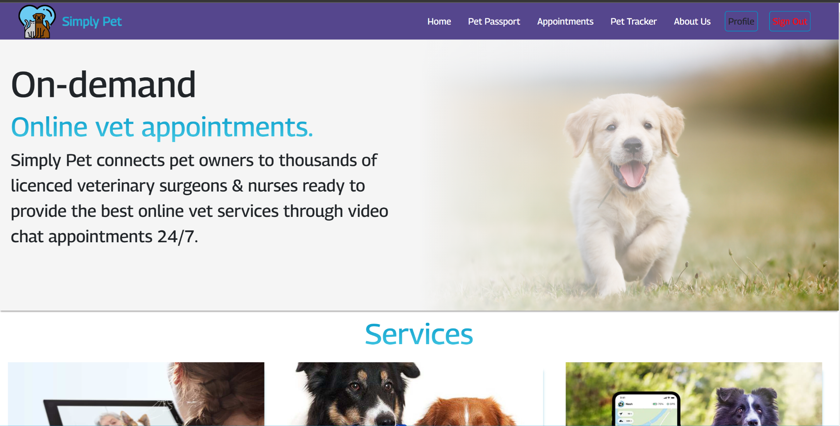

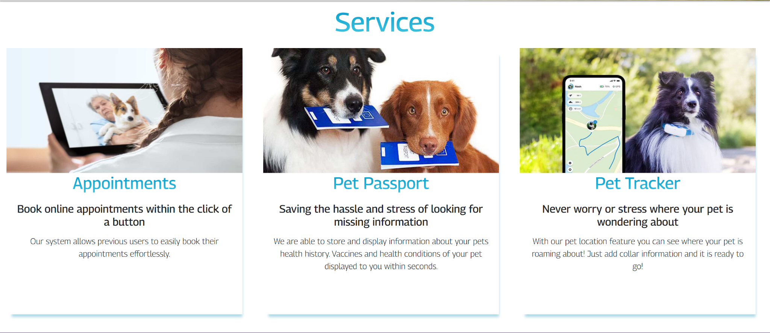

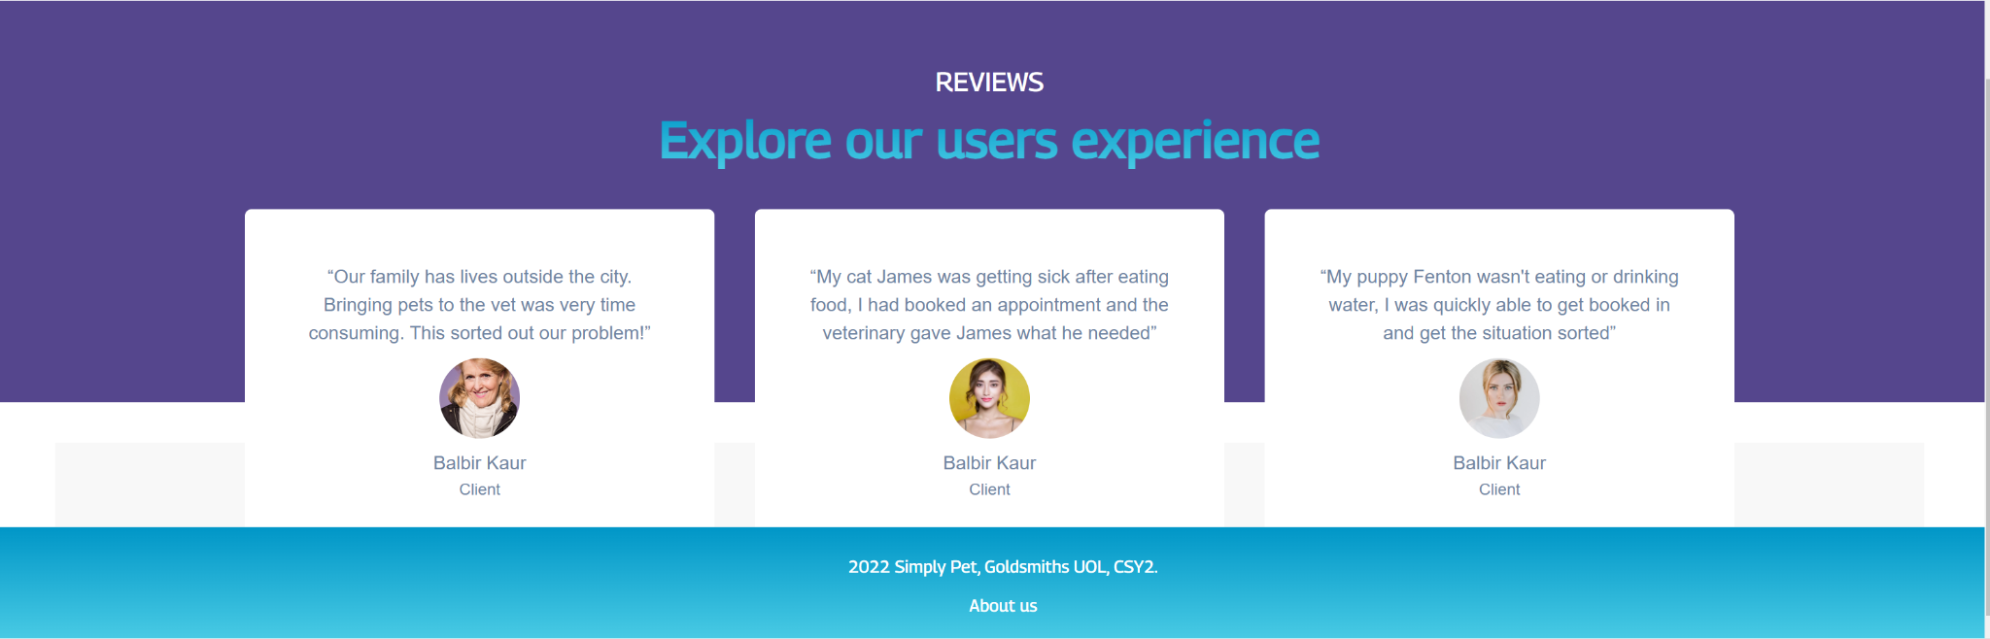

We chose a homepage that is small, basic, and appealing. The major goal is to avoid overwhelming users when they first visit our website. The homepage has a logo in the header, a login-register area in the header, and a link to the about page in the footer.

When browsing the website, the footer and header will always be constant, allowing the visitor to go back and forth easily and logically.

### Log-In & Sign-Up Page

|  |  |
| --- | --- |
|  |  |

The login and sign-up page are just the page where a user can register for the system or log in. Users will log in or create an account by entering their email address and creating a password. If the back end of the system allows it then the user will be able to access the 3 main pages of the website (booking, tracking, passport). The page has a simple interface where the user inputs his information or is asked to sign up.

### Pet Tracker

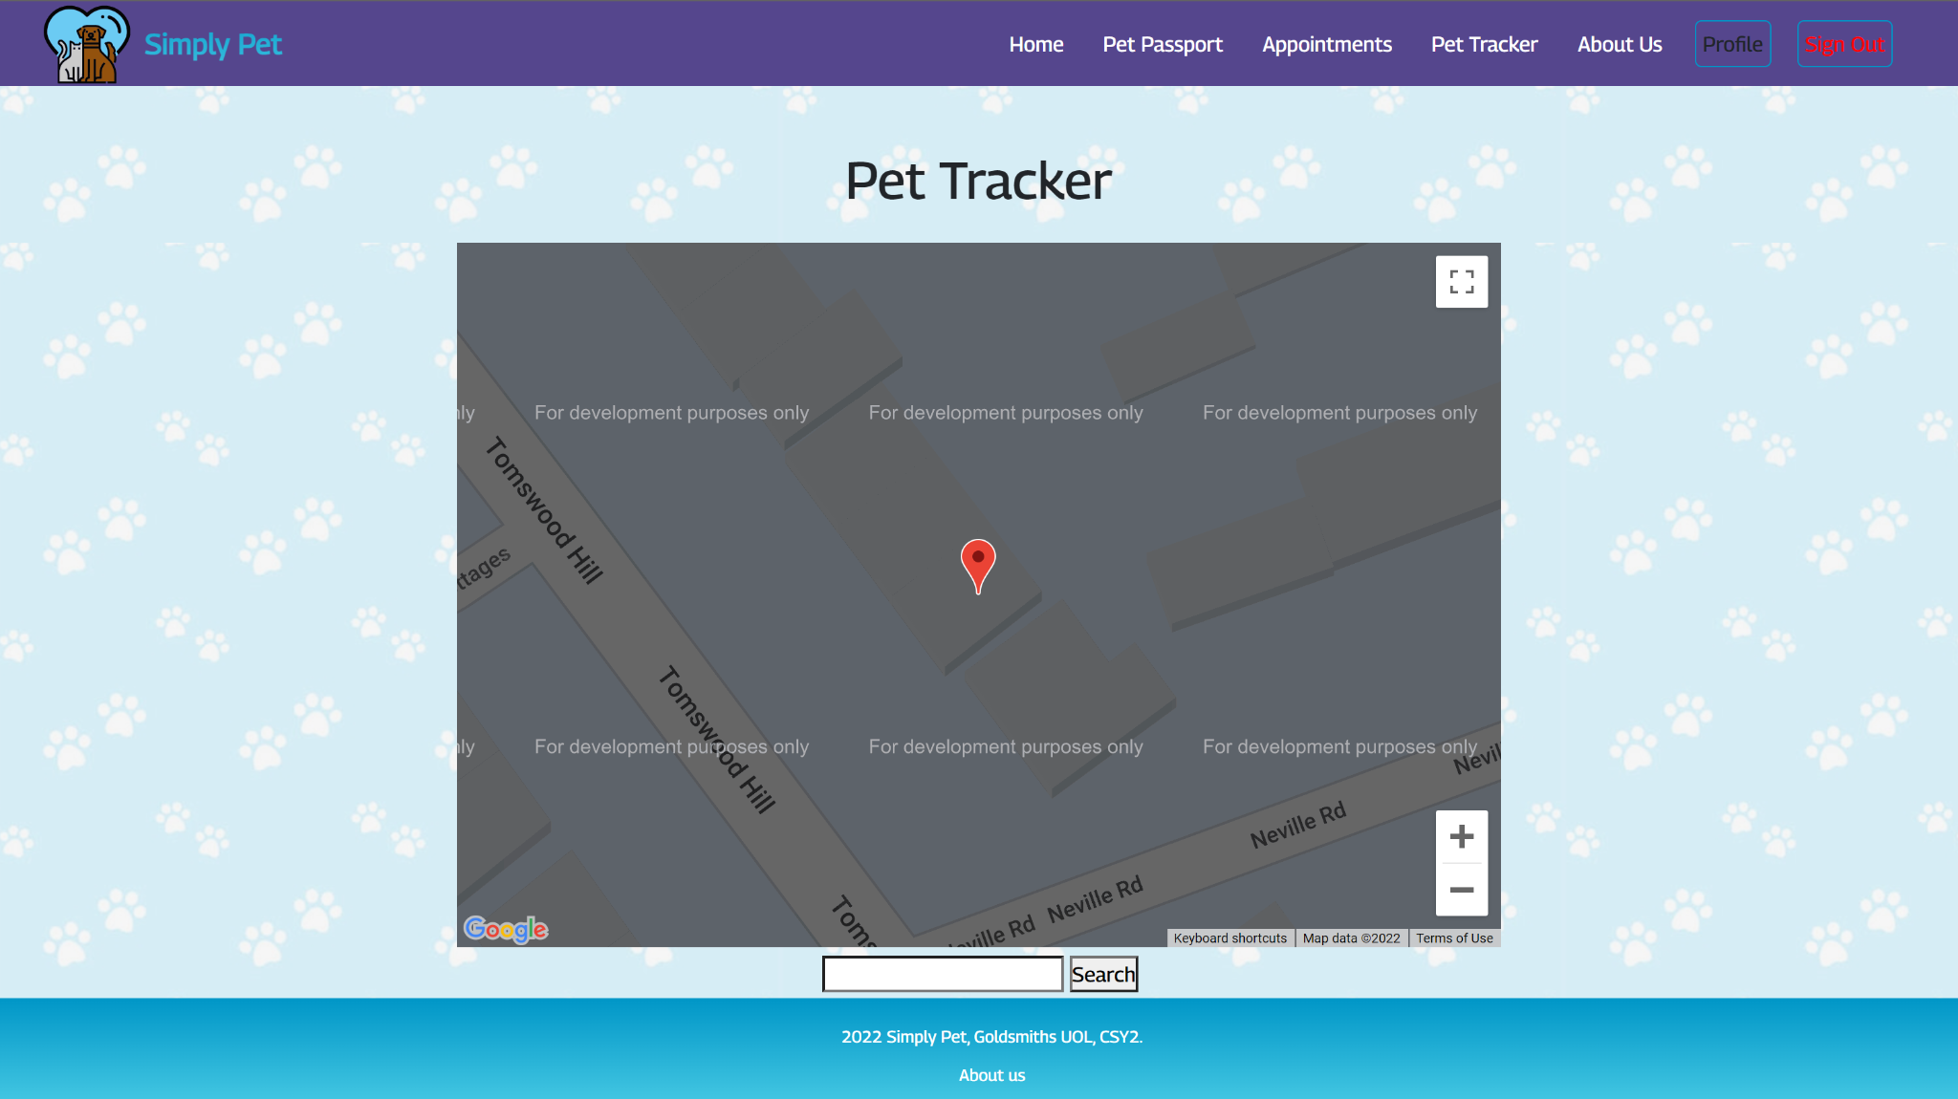

Only accessible if the user is logged in. Using Google Maps API, this page will allow users to track and monitor their pet's whereabouts in real time. The user interface consists of a map with a location bullet for the user's pet. There isn't much you can do in terms of designing the map itself as it is straight forward. The map is the centre of the page and to track their pets’ users must enter the microchip number into the search bar located below to map and they can start tracking their pets. The page is designed this way so the users do not get confused and can start the tracking process as soon as possible.

### Pet Passport

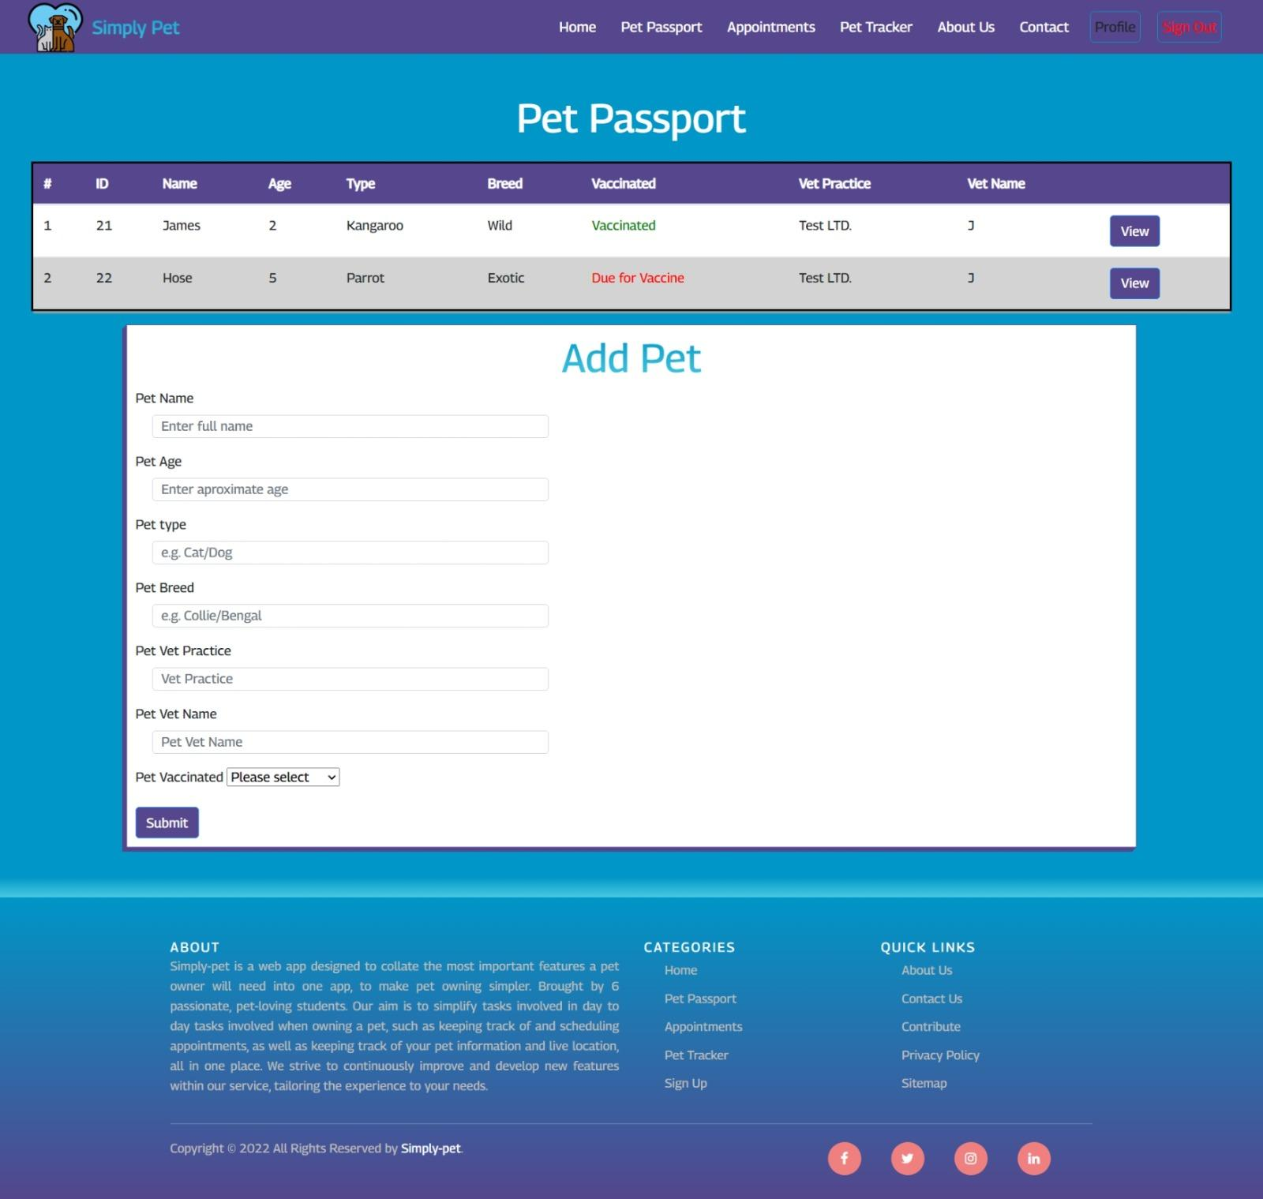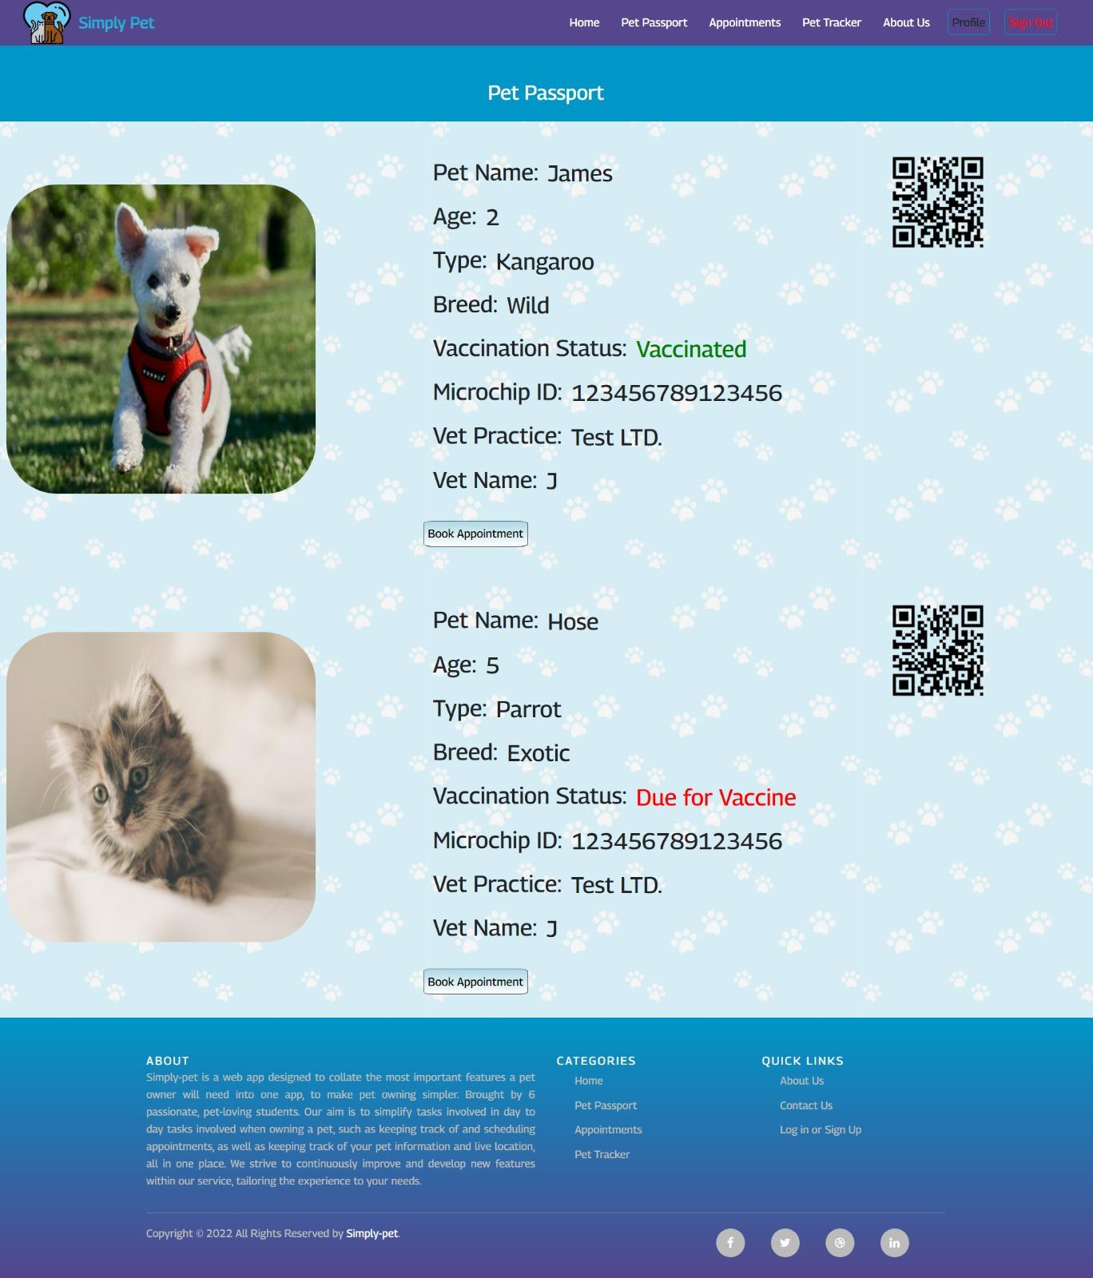

On the pet passport page, the user would be able to input the pet’s details, save them and store the information in his account. On the first picture below, we can see the first layout where the user can see the registered pet, add more, edit, or remove.

Only accessible if the user is logged in. There are not as many resources for designing a pet profiles page, however some elements from user’s profile pages can be used as inspiration. The researched website shows some basics of designing a user profile page, including data that should be displayed to the user (e.g. a profile picture and basic information) as well as provides some layout ideas and theAgenteStudio (*appendix 2.25*) website has also provided useful information on what user profiles should include, which are directly transferable to the pet profile context.Resources found on Inoxoft (*appendix 2.24*), for example, it has enforced the need for intuitive navigation – which can apply to toggling between different pets saved under the user’s account. To accommodate for this, our initial prototyping idea of having a small dropdown of pets in the corner of the page (used to display different pet profiles depending on selection), might not be the most intuitive for some users. We have therefore decided to incorporate a larger, more clear selection section, with id-looking cards for each pet. The article also refers to screen-size. This has also been taken into consideration when designing the pet passport page, making sure that information is clearly visible after resizing the window.

## Booking Page

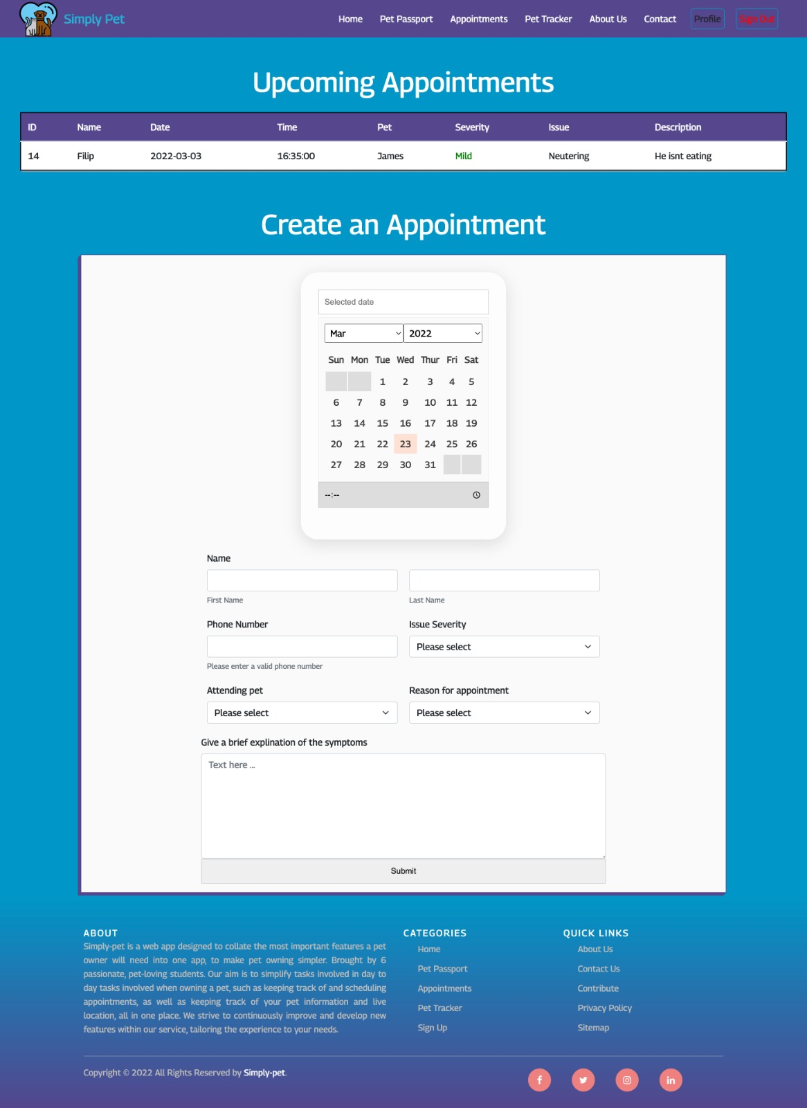

Booking page shows a simple form where the user can add all his details and submit his booking. It is only accessible if the user is logged in. This page will enable users to book appointments with their vet, scheduling slots through the calendar interface and save them in their account.

### About Page

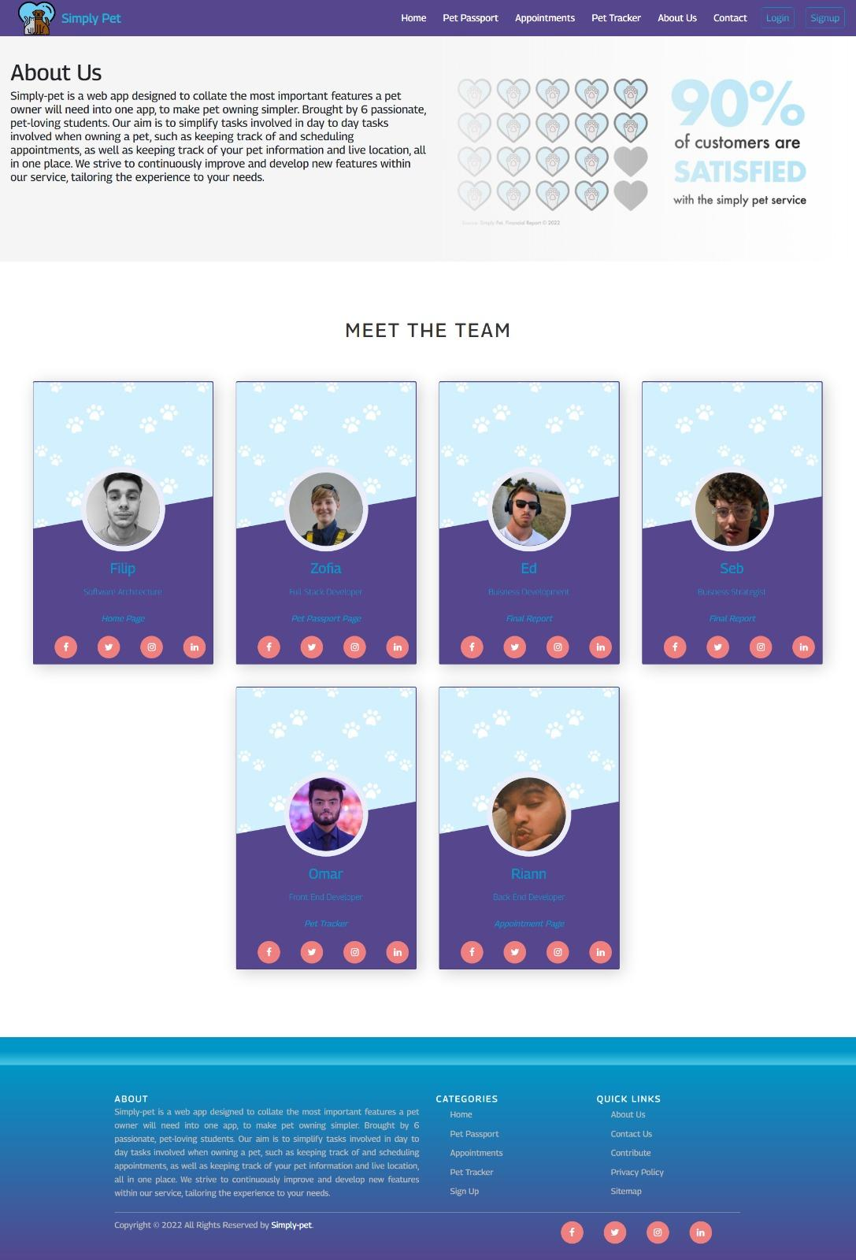

*Appendix* 2.3

The about section will tell users about our personal experiences, backgrounds, mission, and vision for SimplyPet. An about us page may be made in a variety of ways. However, we wanted to create one that was more appealing to the eye, thus the about us page has a design that is comparable to the homepage. We added a section called Meet the Team to that website, where you can see five cards of each individual team member and what projects they've worked on, as well as their social media profiles, so if a user wants to contact one of us, he should have no trouble doing so.

### Contact Us Page

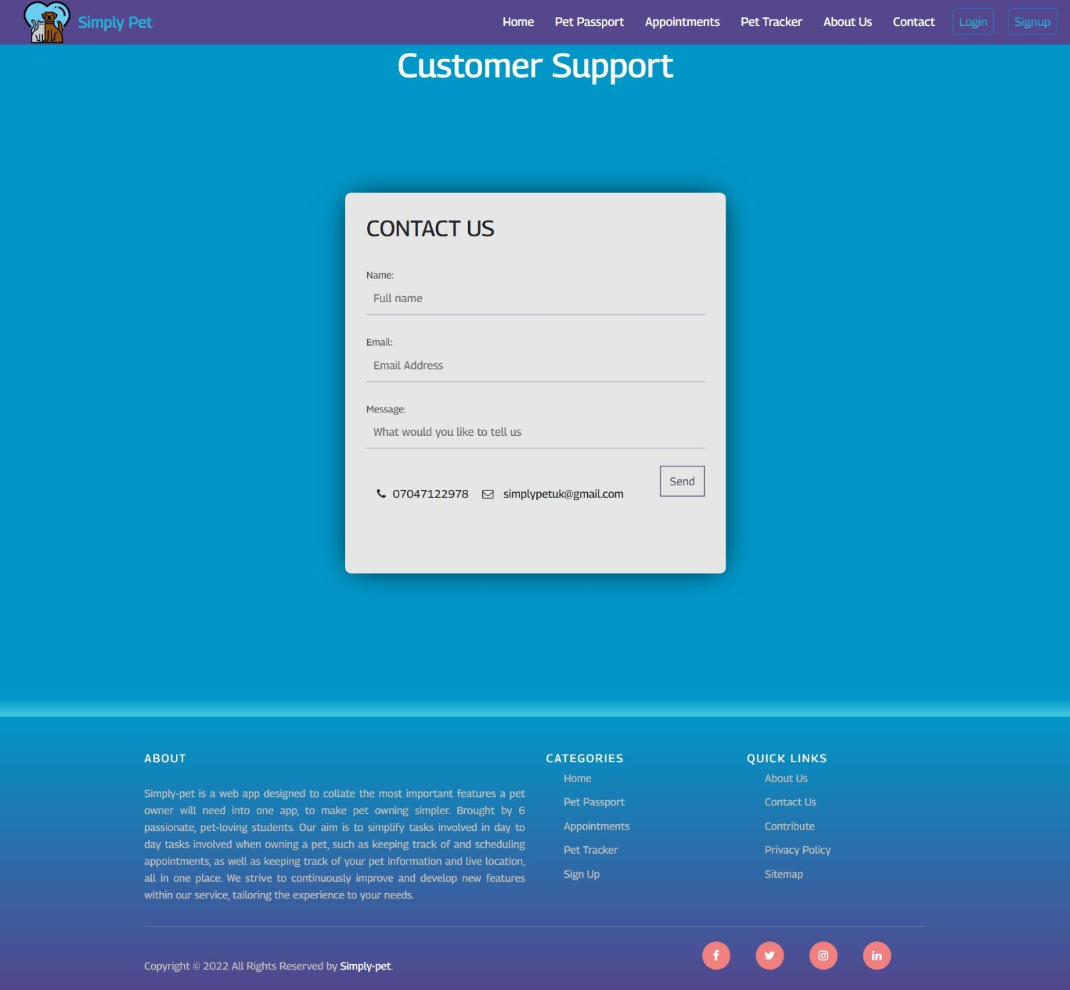

*Appendix* 2.4

A contact Us page will allow users to get in touch with us.

Users may fill out a simple form with their name, email address, and a message for the staff. Will also provide a phone number for customer service and an email address in case they wish to contact us directly. The user will receive an automated email verifying that we have received their inquiry and that we will contact them within 48 hours.

# End-Product Testing

E2E testing is required to assess the product's overall performance empirically (Tsai et. al, 2001). We went through each step of the web application in order, from inputting the URL to logging out and exiting, to properly conduct end-product testing.

We sought to maximise our outcomes given the available time because end-product testing is undoubtedly one of the most time-consuming phases in a product deployment.

Integration testing has always been difficult, especially when the system under test is complex and includes multiple subsystems and interfaces (ibid), and even though our web application is not that sophisticated, it took a lot of hard work to come up with significant results to fully approve and be accepted.

Prioritised for the end user and maintaining the order of the applications the steps taken were:

1. Home Page as a guest
2. Sign In

2.1 add details, log in

2.2 forgot password and retrieve password

1. Sign up

3.1 add details

3.2 confirm email

1. Booking page

3.1 add appointment - select date and time

3.2 edit appointment - select date and time

3.3 select appointment

3.4 cancel appointment

1. Pet passport

4.1 add pet

4.2 edit pet

4.3 remove pet

4.4 share pet passport

1. Pet Tracker

5.1 register device

5.2 enable location service

5.3 share pet location

1. Contact Us

6.1 fill up the form and send enquiry

1. About us

7.1 view team member social media account and details

1. Log out and close the system.

## UI + Usability evaluation

This form of testing will be exploring and evaluating any part of the software that the users have the capability to interact with. For any computer application to perform successfully, it must be able to facilitate the necessary tools for the task at hand in such a way that enables the users to utilise them efficiently (Dillon, n.d.). We will be testing all the visual elements of our software application to evaluate whether they meet the expected requirements for performance and functionality. With regards to said user interface, one must consider the way in which users will consider certain behaviours, which design features will draw their attention and the level of knowledge they will require to respond to software stimulus in a correct and timely manner (ibid).

A high performing user interface must allow users to quickly and accurately absorb visual stimuli presented to them by the software (Marcus et. al, 1991). Current design guidance recommends the use of strong image polarity to provide a contrast between varying elements of the user interface. Users are often resistant to software instruction tutorials and tend to interact with the software regardless of their prior knowledge. Instead of looking towards the removal of erroneous performance, the software should focus on informative and efficient feedback, paired with the ability to undo mistakes to aid and cushion users through the learning process (ibid) i.e. placing an importance on the learnability and memorability of our software application.

We will be evaluating several factors regarding our user interface. Navigational elements will be checked for functionality and accuracy. Data type errors will also be checked, to ensure that only valid data can be entered by the user e.g., numbers for dates and ages. Confirm action buttons will be checked to ensure the users receive confirmation every time they input data, save, or generally interact with the software. Menu items will be evaluated too, to ensure the software application only displays the correct menu items when in specific states of use. We will also be testing end-to-end elements specific to our Software application, such as the process of creating a ‘pet passport’ (Creating and adding details for a user's pet) and the communication channels between users and their vets.

### Testing methods

We will be performing several testing methods to ensure the validity, reliability, and performance of our UI design. Taking inspiration from traditional usability studies (Dôgan et. al, 2014), we will be identifying any problems in the design fundamentals of our software which will subsequently reveal opportunities for us to refine and improve our user interface. We will also gain insightful knowledge into our target user bases’ behaviour and preferences when interacting with our product. This will also test the learnability and memorability of our user interface (Li et. al, 2014).

Due to limited accessibility to advanced automated testing software, the testing type we will undergo will be manual UI testing. Our manual testing will involve numerous participants of varying backgrounds performing different tasks and operations on the software application such as inputting data and viewing relevant information. One of our team members will act as the designated facilitator as they will have extensive knowledge of our software’s user interface. They will guide the participants through the testing process. The participants will be users who would find relevance using our product; promoting a realistic representation of the service being studied. Ten participants from varying demographic and psychographic backgrounds that could be seen as realistic potential users of our software application were recruited to undergo this study. The aspect of our user interface performance to be tested was efficiency (backed against the expected performance in our non-functional requirements) which was recorded with time to complete a task as the single metric.

### Results

Users were instructed to complete the following tasks in order (see tabs below):

1. Create a user account
2. Login using their username and password
3. Log out of their account
4. Change / Retrieve Password

Navigation from the landing Page:

5. Navigate to Pet Passport Page

6. Navigate to the Appointments Page

7. Navigate to Pet Tracker Page

8. Navigate into About Us

9. Navigate to Contact us Page

End to End from the Landing Page

10. Create Pet Passport

11. View Pet Passport

12. Schedule Appointment

13. View Appointment

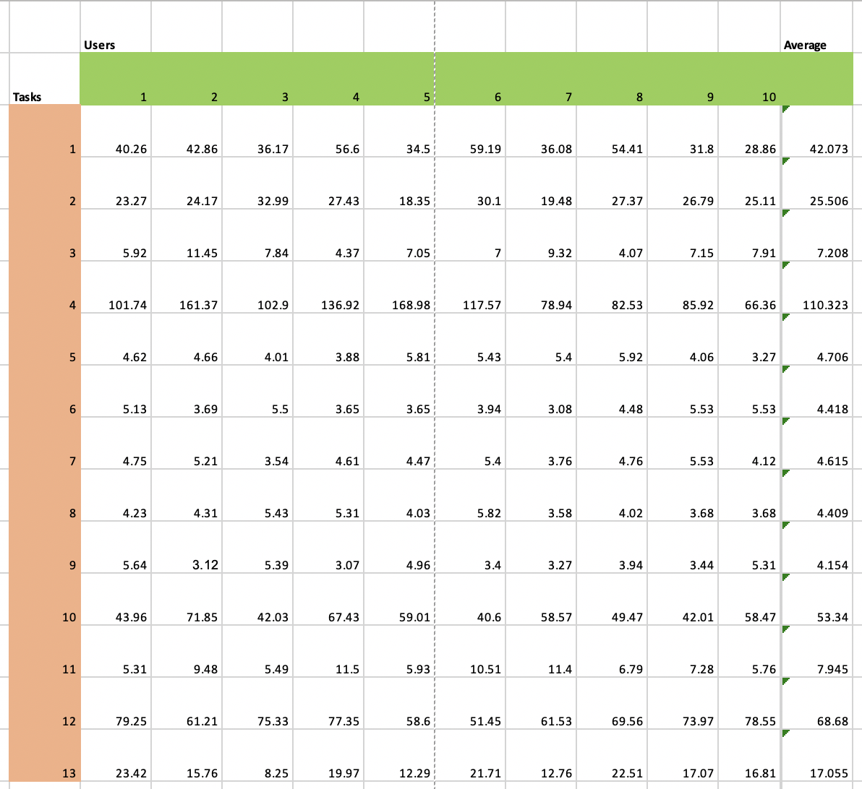The results are displayed in an Excel (*appendix* 2.23) spreadsheet below (1) listing the users and their recorded times for each task they completed. The users are listed in rows from numbers 1-10 and the tasks they have completed are listed in columns from 1 to 13, following the order listed above. Being able to analyse and collect users’ performance data when completing certain tasks is a fundamental part of usability testing. (Sharp et. al, 2015) Evaluating the average time from the users completing tasks can verify that users are able to complete the required tasks in an acceptable manner in accordance to our expected outputs outlined in our non-functional requirements. All the users were able to complete the tasks required of them. It is noted that improvements could be made to the visibility of the log-in and signup buttons as whilst the times fell into an exceptional range per our expected outputs, they performed worse than the other tasks in comparison. There were no exceptional outliers noted.

(1) Excel spreadsheet listing the users and their recorded times for each task they completed.

UX Evaluation

The UX or user experience encountered when a user interacts with a product can be described as “all aspects of the end-user's interaction with the company, its services, and its products.” (Nielsen et. al, 2014) It goes beyond a user's performance when interacting with a product, but their impression and feelings towards the product; the quality of the experience they had. One cannot design a user experience, but simply design with a positive user experience in mind (op cit). The experience must instil a sense of value towards the product in the user, as well as a sense of trust. Reaching further, one should also consider users' design influenced presumptions and expectations that can affect their experience when interacting with a product. (McCarthy et. al, 2004) When performing our UX evaluation, we must determine all points of contact between the user and the product. This includes the interaction with the web application itself, any subsequent manuals and documentation that accompany the software and its ‘in the field’ usage, e.g., tracking one’s pet or displaying the pet passport to your local vet. The product's accessibility must also be considered.

### Testing methods

When evaluating the UX when interacting with the web application, we will use ‘think aloud’ testing. Think aloud testing encourages users to verbalise their thoughts and feelings when interacting and moving through the interface. (Nielsen, 2010) This is a flexible testing model that will provide us with a lot of qualitative feedback directly from users. We can also use this testing method throughout multiple stages of the development lifecycle - utilising different users each time - suitable as we are utilising an *agile framework.* Five participants were instructed to navigate and interact with the web application freely as to position them into a more natural situation when conducting this study, though were encouraged to explore all the pages on the site. During this, they were encouraged to voice their thoughts and opinions out loud. They are then asked to summarise their overall experience at intervals (between sections) with ratings “very negative”, “negative”, “neutral”, “positive” and “very positive”.

### Results

The results are divided between the five main pages: Home, Pet Passport, Pet Tracker, Appointments and Contact us. The data is summarised into bar graphs and any statements or queries worth noting during the study are recorded below:

## Home Page Analysis

## Notable Thoughts

* “Good use of a landing header, clear and concise, I know what the website is about from the get-go”
* “Colour contrasts aren’t that visually appealing, with the blue and purple clash”
* “Logo doesn’t sit very well against the purple”
* “Good Contrast for the menu bar bit, the white against purple is easy to read”
* “I like how I can scroll down and there are other bits of information available [...] I don’t have to click off the home screen instantly”

## Pet Passport Page Analysis

### Notable Thoughts

* “There could be more spacing between the border and the current appointments bit”
* “The background could be a more appealing colour and have some gradient to it”
* “I like the green and red for vaccinated or not vaccinated”
* “It's easy to read but feels like it could be positioned a bit better”
* “The paw print background when you click on a pet is a bit 90’s”

## Pet Tracker Page Analysis

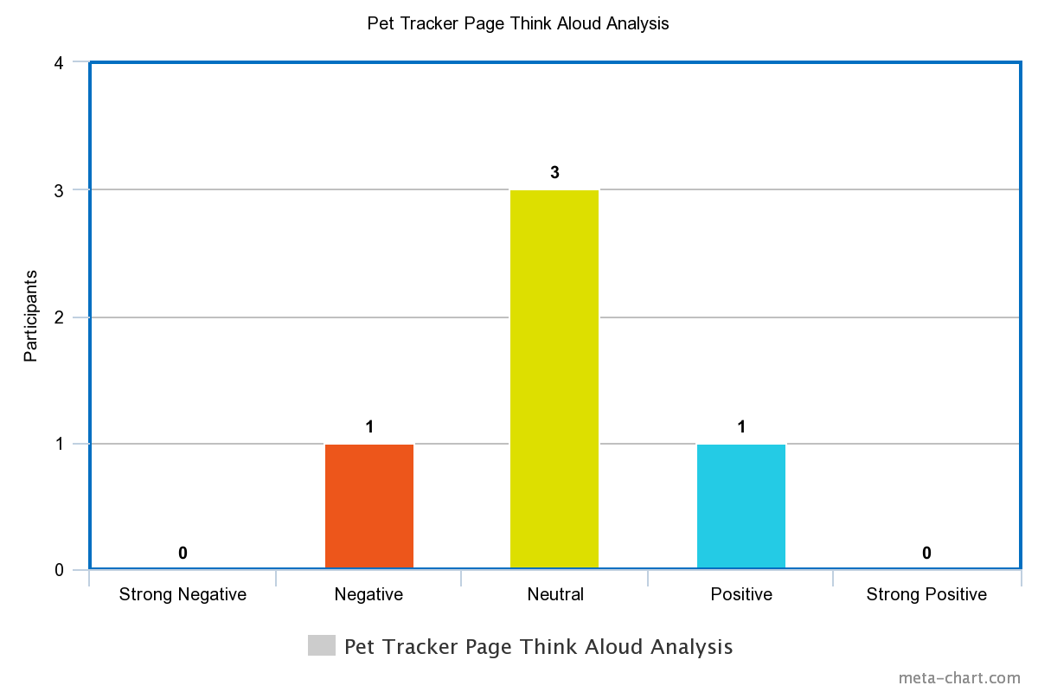

### Notable Thoughts

* “Still not a fan of the paw print background”
* “It’s not very clear how you would use this to track a pet”
* “What is entered in the search area?”
* “I think some borders around the map specifically could make it look a bit nicer”

## Appointments Page Analysis

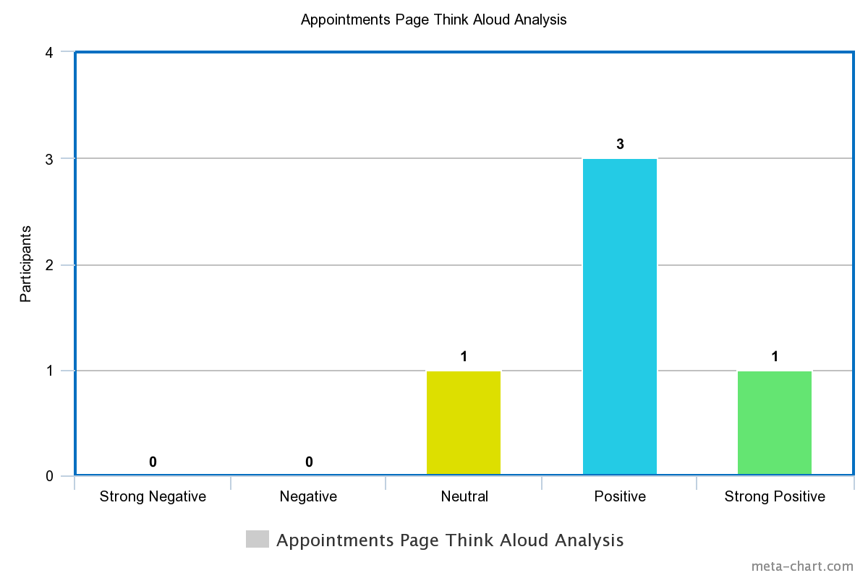

### Notable Thoughts

* “The calendar looks really clean and modern”
* “The spacing between items is done better on this page”
* “It’s easy to understand”
* “I’m not a fan of there being a second header [...] in that style”

## 

## 

## Contact Us Page Analysis

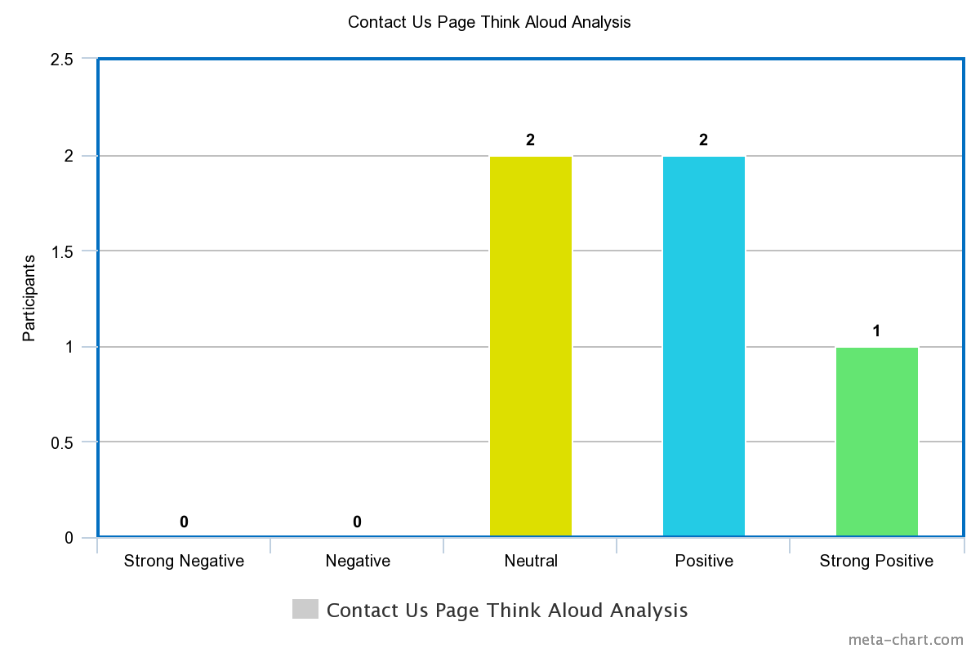

### Notable Thoughts

* “The form looks really professional”
* “The contact us bit could be placed a bit higher up and the customer service title placed a bit lower down”
* “Again, simple and nice”
* “The placement of the items on the screen could be readjusted”

### Conclusion

Analysing the key points made by our user testing it is clear to see a common theme amongst some of our design specifications. Users were not particularly fond of the paw print background as it did not align with their views of a modern looking website and preferred the pages where it was replaced with a clear opaque background. They also felt some of the padding around particular objects on pages could be improved to remove cramping. This was particularly noted on the forms and pet passports. They felt (with exception to the geo tracker) that it was a friendly looking and easy to understand website but some of the colour combinations weren’t easy on the eye as they clashed, such as the purple and blue; they preferred the higher polarity combinations such as the white text blue background navigation bar on the home screen. There was only one incident of neutral feelings towards a page (the geo tracker) and the primary feelings and thoughts expressed towards the pages and website were overarchingly positive, coupled with a few neutral responses, primarily catering to easily remedied problems such as the backgrounds and object padding. The consensus by our testers has shown that whilst there are areas for improvement, our web application meets user experience performance needs outlined in our non-functional requirements and initial research prior to the results.

## Functionality Evaluation

Functionality testing, although underestimated for a long time in project management (Lech, 2013), will allow us to test and evaluate whether all parts of the system are working as intended. We will be validating our specific functions of our software application by providing appropriate inputs and validating the outputs against the expected results outlined in our functional requirements. We will cover all the main functions in our testing such as creating / logging into accounts, creating / viewing pet passports, using the geolocation feature and scheduling appointments in the calendar. These tests will be performed in all the main web browsers identified as being used in our market research: Safari (*appendix* 2.17), Google Chrome (*appendix* 2.18) and Firefox (*appendix* 2.19). This is to ensure maximum accessibility to our market users (Saar et. al, 2014).

### Error handling

We will also be testing the software’s error handling. This is to ensure the system can deal with any sort of errors under any circumstances that may occur during use (Weimer et. al, 2004). We will be using the standard testing protocol when doing error handling evaluation which goes as follows:

### Test driven development and unit testing

Unit testing relates to the practice of validating small and specific portions of code (Garousi et. al, 2013). The test is coded in an automated process where the data is passed through the code and evaluates whether the output matches the expected result. We have utilised the software practice known as test driven development. This is an approach where unit tests are written before the code is implemented. Unit testing cases using minimal code that perform the primary function of the area are created then tested. The test is then run, and any necessary refactoring is subsequently completed. This moderate increase in development effort greatly reduces the error rate in our coding process. The tests are small in scope and are run frequently to minimise backtracking to resolve errors. Our test-driven development process is outlined below:

1. Setting up the testing environment
2. Generating cases for the test
3. Executing the test cases
4. Results and analysis / refactoring
5. Re-testing

The test environment is set up in accordance with the test being run. Significant data such as user login details will be stored elsewhere to ensure no losses if a crash occurs. We will be generating different cases that may result and provoke errors in our software, such as entering incorrect data types when filling out the Pet Passport. We will then analyse the results and compare them to the expected results detailed in our functional requirements. If the tests fail, the code is refactored, and the process is repeated until the expected outputs are met.

# Evaluation Plan

## User evaluation involving representative stakeholders

We acquired enough data from our initial research into stakeholders' requirements and expectations to completely comprehend the aims and goals we were striving for as we moved into the development process.

Initially, several stages of the apps were tested and presented to gather feedback and repeat based on it and comparing the initial MVP to the final one provided us a clear idea of the requirements we needed to set and keep throughout the development period.

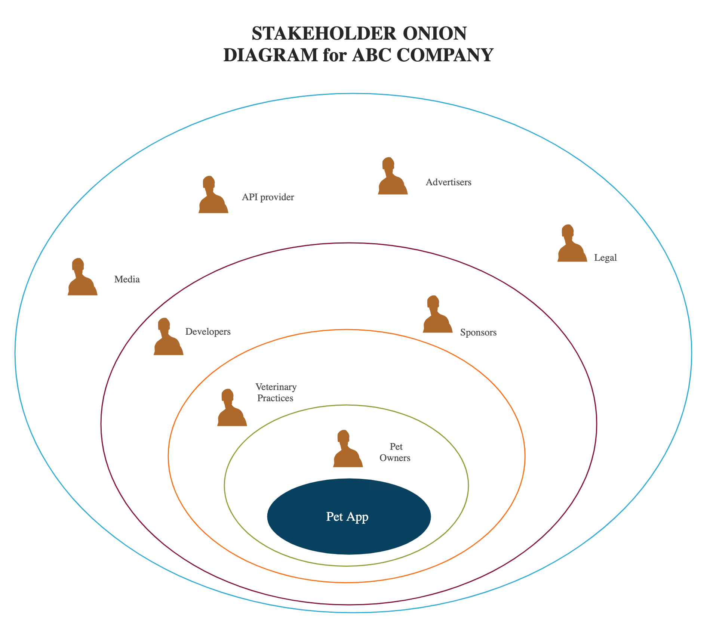With image below taken from the first report, we can observe who the stakeholders for SimplyPet are:

*Stakeholder diagram*

We focused our summative stakeholder evaluation only on the first 3 circles in the following order:

#### 1. Pet owners

They considered the app to be incredibly useful and usable, and based on our testing, they were all able to effectively run our app and were excited to see a genuine version hit the market soon.

In terms of earning points, the function of storing pet records was the most popular, and it was deemed extremely essential to them since the challenge to keep records in order and on track even while working remotely is a real user requirement.

The booking system has also been quite successful, however they noted that because the programme is still in its early stages, the few functions may make it more difficult than just calling the veterinary services.

Pet trackers have also been viewed favourably, albeit it may be claimed that because most pets nowadays are not connected to any GPS device, the function may be rendered worthless for many.

#### 2. Veterinary Practices

Although veterinary offices were not as active in the process as pet owners, they played an important part in the MVP draft, because one of SimplyPet's primary features is the ability to arrange an appointment with them.

The veterinarians questioned all expressed reservations about the booking system's practicality, believing that we would not be able to maintain a clear and error-free system. Overbooking and malfunctions were the two major factors that caused us to consider how critical it would be to incorporate a fully working and tested environment to prevent causing more harm than good. SimplyPet's long-term goal is to make pet owners' and veterinarians' life simpler by enabling them to be less engaged in the booking system. For now, we've kept the functionality simple, and with more time, we'll grow it into a more complex booking system (see future work description). Our functionality appealed to small practices with little resources, making it potentially beneficial in terms of recruiting new customers and, as a result, extra bookings. Big practises with an online ecosystem thought this would just be another platform for them, but small practices with fewer resources found our feature very appealing and potentially remunerative for acquiring future customers and thus more bookings.

#### 3. Developers

The developers' judgement has been challenging since they are biased towards the entire process because they developed it. Despite the positive and inspiring comments, they recognise the need of maintaining and producing high-quality work to ensure SimplyPet's success and survival against prospective competitors soon. Taking a new perspective on the project, they are confident in their ability to deliver and excited to take SimplyPet to the next level in terms of UX, back end, and design.

#### 4. Sponsors

Sponsors are going to be critical to SimplyPet's long-term survival and development. We attempted to interview a few potential angel investors and gathered some helpful feedback that would help them develop and enter this enterprise with ease.

The sponsors' major aim was to be able to follow and foresee an exit plan, and they wanted to know how we might help them with that.

Their idea was to include veterinary offices in the marketing phase, encouraging them to promote our platform and to join a partnership programme in which each veterinarian practise would pay us a fee for each reservation made through our platform.

Another tip they provided us was to include pet service advertisements and partners in the region. This would enhance income and allow us to establish a network of pet services in one location, benefiting many small companies in the area.

## Evaluation

To assess our project management, we all got together and spoke about what went well and what didn't, as well as what we would do differently, how, and why if we had to do it all over again.

One of the things we agreed on was that, after seeing how successfully the second phase of the project went, separating the team into smaller groups could have been a good idea in the first portion as well, as we found it to be quite beneficial and efficient.

​​In terms of development, it was tough to communicate with one another when things were past due but owing to strong soft skills and straightforward and open communication, we were able to talk about it and appreciate how important this project was to all of us, expressing our own goals and objectives. This significantly increased the level of effort and time each of us invested in the project, allowing us to make significant progress in a short period of time.

Another observation is that the pet tracking system we have devised thus far may not be sufficiently robust to please our consumers; for example, certain pets may not have a GPS device, and the microchip may not be compatible with the GPS network. Overall, it could have been preferable to focus more on the scheduling and pet passport functions, but we did manage to construct a working website that locates pet owners and can successfully locate the pet by inputting the GPS device code.

### Future Work

Although this project taught us how difficult it is to make things function, even if they are few and simple, there are things we would like to work on and develop in the future.

One of the first goals would be to create an ever-growing database of veterinary clinics that would allow users to evaluate and review them, as well as filter them based on ratings, price, and location.

Even though the pet location feature is currently quite limited, it could be expanded to allow users to not only locate their pets but also set alerts for when their pet's distance from the set location or the user's location exceeds a certain threshold (e.g., when the pet is 2+ miles from the set location or the user's location).

The booking system would also be improved, allowing you to send reminders and automatically construct email/SMS as reminders or booking confirmations in conjunction with calendar events in Google and Apple calendars. In addition, Maps APIs will be used to direct you to the practice at the time of your appointment.

Additionally, we would have added a function to the calendar that shows which dates are already booked by other patients, so that the calendar only shows the dates with available appointments. I believe this would have been beneficial, allowing the system to spread appointments out across several days or weeks, avoiding a potential overflow of users at the same time. This approach may have been used not just with dates, but also with available times within a single day.

Finally, we would have included a function that allowed users to upload material, such as photos or videos, of their pets to demonstrate their issues or concerns.

Pet passports, which are now only available to users/veterinary practises, might be expanded further to become an official document that can be downloaded in digital format and used to travel abroad, share with insurance companies, and so on.

Simply Pets survival and future growth will also depend on having a sound monetisation plan in place. Pet services providers, such as pet stores and pet sitters, social pet friendly events, and a blog/forum where users can express their opinions or experiences with their animals are just some of the concepts that might be incorporated at a later stage.

In terms of usability and accessibility, improving the overall design, and creating a mobile application for both Android (*appendix* 2.20) and iOS (*appendix* 2.21) would be an essential step, allowing consumers to access the services at any time and from any location.

# Ethical Audit

When it comes to our web-based application, there are several factors to consider maintaining the greatest levels of ethics and privacy.

Beginning with the premise that everyone should be able to utilise web apps, the system has been developed on a foundation of continual development, with accessibility at the forefront. Conducting usability, accessibility, and responsiveness testing with real-world users aided us in the process of ensuring the application was usable, accessible, and responsive.

We also believe in sharing information and assisting other developers working on similar projects, which is why the project will be open source and available through websites like GitHub and GitLab (*appendix* 2.22).

On the other hand, there is a backend system for a website, there are plenty of things to consider. Security and data privacy are most likely the most crucial aspects to protect to provide a seamless user experience and peace of mind (McConnell, 2004). Because our system requires the usage of cookies, it is critical that we guarantee that the data is secure and that it is not shared with third parties unless absolutely required, as this may easily endanger the user's privacy. (Zimmerman, 2000).

Given that we are utilising a third-party API, it may be worthwhile to investigate several choices and select the safest and most stringent in terms of data privacy protection (Doty et. al, 2010). The location of their pets, as well as any other sensitive private information they reveal about themselves and their pets (email, password, address, etc.) shall be kept completely confidential and not shared with third parties unless the user chooses to do so. Maintaining a strong security protocol and making sure we're taking appropriate precautions to keep people and their data safe (Bélanger et. al, 2011).

To achieve those security standards, the measures we have put in place are:

* Unauthorised access is not permitted to the database where the user credentials are kept.
* The application only accepts one set of credentials at a time (no duplicate user IDs or emails).
* At no time is the password visible in any section of the programme.

# Conclusion

SimplyPet cleared the path for a significant shift in how pet owners maintain track of their animals and manage their interactions with veterinarians.

We expect that more and more individuals will require such an app for their everyday needs relating to their dogs, as evidenced by the extensive study undertaken prior to development and the testing and research conducted after the prototype was created.

Because mobile and online apps are here to stay, we must ensure that usability and user experience only serve to support and ease the user's wants and objectives.

Today's technology has made information more accessible than ever before, which is why we believe SimplyPet will considerably reduce the need for users to maintain their pet data organised and visible in the case of a vacation, a medical appointment, or a pet loss. Veterinary clinics sometimes lack the infrastructure needed to support larger-scale bookings, which we feel might be an asset for monetisation in the future.

This group project experience has taught us a lot about teamwork and software development but also about pet’s management and user needs. Therefore, if we had more time and resources, we would absolutely invest more into the development of Simply Pet and make it a reality rather than a university project.

Simply pet offers the groundwork for an engaging and useful tool for pet owners and veterinary practices, with a wealth of possibilities and opportunities.

# Bibliography

Bélanger, F. and Crossler, R.E., 2011. Privacy in the digital age: a review of information privacy research in information systems. *MIS quarterly*, pp.1017-1041.

Bourdieu, P. (1986). The forms of capital. In: Richardson, J., Handbook of Theory and Research for the Sociology of Education.

Blank, S., 2013. Why the Lean Start-Up Changes Everything. *the Magazine,* May.

Dillon, A., n.d. User Interface Design Introductory Article. *User Interface Design*, [online] Available at: <https://www.researchgate.net/profile/Andrew-Dillon-5/publication/227998407_User_Interface_Design/links/5c75aaa692851c695043accc/User-Interface-Design.pdf> [Accessed 14 February 2022].

Doğan, S., Betin-Can, A. and Garousi, V., 2014. Web application testing: A systematic literature review. *Journal of Systems and Software*, *91*, pp.174-201.

Doty, N., Mulligan, D.K. and Wilde, E., 2010. Privacy issues of the W3C Geolocation API. *arXiv preprint arXiv:1003.1775*.

Duc, A. N. & Abrahamsson, P., 2016. Minimum Viable Product or Multiple Facet Product? The Role of MVP in Software Startups. *Agile Processes, in Software Engineering, and Extreme Programming,* Volume 251.

Gaikwad, SURAJ SHAHU, and P. R. A. T. I. B. H. A. Adkar. "A review paper on bootstrap framework." *IRE Journals* 2.10 (2019).

Gardner, Brett S. "Responsive web design: Enriching the user experience." *Sigma Journal: Inside the Digital Ecosystem* 11.1 (2011): 13-19.

Garousi, V., Mesbah, A., Betin-Can, A. and Mirshokraie, S., 2013. A systematic mapping study of web application testing. *Information and Software Technology*, *55*(8), pp.1374-1396.

Kumar, P.P., 2005. Effective use of Gantt chart for managing large scale projects. *Cost engineering*, *47*(7), p.14.

Lech, P., 2013. Time, budget, and functionality?—IT project success criteria revised. *Information Systems Management*, *30*(3), pp.263-275.

Li, Y.F., Das, P.K. and Dowe, D.L., 2014. Two decades of Web application testing—A survey of recent advances. *Information Systems*, *43*, pp.20-54.

Marcus, A. and Van Dam, A., 1991. User-interface developments for the nineties. *Computer*, *24*(9), pp.49-57.

Miara, Richard J.; Musselman, Joyce A.; Navarro, Juan A. & Shneiderman, Ben (November 1983). ["Program Indentation and Comprehensibility"](http://www.cs.umd.edu/~ben/papers/Miara1983Program.pdf) (PDF). *Communications of the ACM*. **26** (11): 861–867. [doi](https://en.wikipedia.org/wiki/Doi_(identifier)):[10.1145/182.358437](https://doi.org/10.1145%2F182.358437). [S2CID](https://en.wikipedia.org/wiki/S2CID_(identifier)) [11767796](https://api.semanticscholar.org/CorpusID:11767796). Retrieved 3 March 2022.

Mccarthy, J. & Wright, Peter. (2004). *Technology as Experience.* [online] Available at: <​​https://www.researchgate.net/publication/224927635_Technology_as_Experience>[Accessed 22 February 2022].

[McConnell, Steve](https://en.wikipedia.org/wiki/Steve_McConnell) (2004). [*Code Complete: A practical handbook of software construction*](https://archive.org/details/codecomplete0000mcco). Redmond, WA: Microsoft Press.

Moin Shaikh, F., Sabir, S. and Abbas, D., n.d. *An Optimised Approach for Graphical User Interface Testing*. [online] Islamabad. Available at: <https://www.researchgate.net/profile/Shaista-Sabir-3/publication/318531643_AN_OPTIMIZED_APPROACH_FOR_GRAPHICAL_USER_INTERFACE_TESTING/links/596f5334aca27227101361f0/AN-OPTIMIZED-APPROACH-FOR-GRAPHICAL-USER-INTERFACE-TESTING.pdf> [Accessed 14 February 2022].

Moogk, Dobrila Rancic. "Minimum viable product and the importance of experimentation in technology startups." *Technology Innovation Management Review* 2.3 (2012).

Nielsen, J., 1993. Response Time Limits: Article by Jakob Nielsen. [online] Nielsen Norman Group. Available at: <https://www.nngroup.com/articles/response-times-3-important-limits/> [Accessed 15 March 2022].

Nielsen, J., 2010. *Usability engineering*. Amsterdam: Morgan Kaufmann.

Karreman, Joyce, Thea Van Der Geest, and Esmee Buursink. "Accessible website content guidelines for users with intellectual disabilities." *Journal of applied research in intellectual disabilities* 20.6 (2007): 510-518.

Krishnan, S.P.T. and Gonzalez, J.L.U., 2015. Google Cloud SQL. In *Building Your Next Big Thing with Google Cloud Platform* (pp. 159-183). Apress, Berkeley, CA.

Perfecto by Perforce. 2022. *UI Testing: A Comprehensive Guide | by Perforce*. [online] Available at: <https://www.perfecto.io/blog/ui-testing-comprehensive-guide> [Accessed 14 February 2022].

Porter, M. E., 1989. How Competitive Forces Shape Strategy. *Readings in Strategic Management..*

Ries, E., 2011. *The lean startup: How today's entrepreneurs use continuous innovation to create radically successful businesses.* S.l.:s.n.

Rugman, Alan M., and Joseph R. D'cruz. "The" double diamond" model of international competitiveness: The Canadian experience." *MIR: Management International Review* (1993): 17-39.

Saar, T., Dumas, M., Kaljuve, M. and Semenenko, N., 2014, July. Cross-browser testing in browserbite. In *International Conference on Web Engineering* (pp. 503-506). Springer, Cham.

Sabbaghi, A. & Vaidyanathan, G., 2004. SWOT Analysis and Theory of Constraint in Information Technology Projects. *Information Systems Education Journal,* 13 April.2(23).

Sharp, H., Preece, J. and Rogers, Y., 2015. *Interaction design: Beyond Human-Computer Interaction*. 4th ed. [online] Available at <http://prof.mau.ac.ir/images/Uploaded_files/Jenny%20Preece,%20Helen%20Sharp,%20Yvonne%20Rogers-Interaction%20Design_%20Beyond%20Human-Computer%20Interaction-Wiley%20(2015)[369707].PDF> [Accessed 22 February 2022].

Tilkov, S. and Vinoski, S., 2010. Node. js: Using JavaScript to build high-performance network programs. *IEEE Internet Computing*, *14*(6), pp.80-83.

W. T. Tsai, Xiaoying Bai, R. Paul, Weiguang Shao and V. Agarwal, "End-to-end integration testing design," *25th Annual International Computer Software and Applications Conference. COMPSAC 2001*, 2001, pp. 166-171, doi: 10.1109/CMPSAC.2001.960613.

Webaim.org. 2022. *WebAIM: Contrast Checker*. [online] Available at: <https://webaim.org/resources/contrastchecker/> [Accessed 18 February 2022].

Weimer, W. and Necula, G.C., 2004, October. Finding and preventing run-time error handling mistakes. In *Proceedings of the 19th annua*

Wixon, D. and Wilson, C., 1997. *The usability engineering framework for product design and evaluation*. 2nd ed. Amsterdam. [Accessed 22 February 2022].

ZIMMERMAN, Rachel K. The way the cookies crumble: internet privacy and data protection in the twenty-first century. *NYUJ Legis. & Pub. Pol'y*, 2000, 4: 439.

# Appendices

## Meeting Log

|  |  |  |
| --- | --- | --- |
| **Date** | **Place & Attendance** | **Summary** |
| Wednesday  19/01/22 | Team Meeting  09:00 - 10:00 (GMT)  All present | We got together to discuss and evaluate the first assignment mark, we read through the feedback and worked out what the expectation is for this next chapter. We allocated 2 meetings a week for this second assignment Wednesday morning and Monday am. |
| Monday  24/01/22 | Team Meeting  11:00 - 12:30 (GMT)  All present | Walked through the rubric for the assignment and listed a to-do list of things to run through. Set up new slots on Trello for project management and defined and created a new report structure. |
| Wednesday  26/01/22 | Team Meeting  09:00 - 10:00  Zofia, Ed, Fil. | Discussed software developments steps and stilled the next steps: set up a coworking development environment so we can all contribute and have access. Created a new Trello board for the second part of the assignment. First, look at reactJS. Drafted technical questions to ask Sean on Thursday’s lecture.  We will use Visual Studio as IDE, Fil will set up a GitHub, and introduce the environment to the group to make it evenly accessible and fully collaborative. The aim is to have a headings structure for the report done in the next meeting on Monday 31st. |
| Monday  31/01/22 | Team Meeting  12:00 - 13:00  Zofia, Ed, Fi, Seb. | Explained to everyone how we are going to work on GitHub, set up a terminal command to save and change code. We will pull requests each time we want to commit a change and someone else from the group will have to approve. By doing so we will keep track of all versions and be able to collaborate efficiently. Considering the idea of only focusing on mobile or web apps instead of doing both. Wednesday we will define the report structure and headings and start coding. |
| Wednesday  02/02/22 | Team Meeting  9:00 - 10:00  Seb, Fil, Ed, Zofia. | Ed worked on the headings and table of contents, finished the first draft, and finished setting up git with Fil for the collaborative code environment. Zofia will organise the report heading on the report as she did very well on part 1, Fil sorted the git issues we were having and set it up properly for all. Seb started making research on what testing might be more efficient for our software. We will meet Saturday to start coding and assign specific coding tasks to each of us. |
| Saturday  05/02/22 | Team Meeting  11:00 - 12:00  Ed, Omar, Fil. | Fixed an issue preventing Ed from effectively uploading and committing changes on git. We went through the same thing with Omar and set git properly with the right SSH keys.  We started basic coding for the html index and routing. |
| Wednesday  09/02/22 | Team Meeting  09:00 - 10:00  Ed, Omar, Zofia, Seb, Riann, Filip. | Discussed and evaluated Sean's feedback from Tuesday 8th lecture.  Riann, Oma, Fil, Zofia: Dev side - tasks will be split in further meetings, where more specific roles will be determined within this group. General run through of what will need to be done has been discussed during the meeting. This includes re-evaluating what information will need to be stored and how on the database, as well as discussing basic formatting we will use across the web app. Filip will draft the first page of the web app, which will be used to consistently format the rest of the project.  Seb - Ed: Report (as business focus programs), testing, evaluation, etc. work alongside and with the development side group to keep iterating and pivoting what does and doesn't work.  Set up a meeting in person for next Tuesday in the library to cover up Sean's feedback and have the chance to reiterate it at next Thursday's lecture. |
| Saturday  12/02/2022 | Team Meeting  11:00 - 12:00  Ed, Seb, Zofia, Riann, Filip, Omar. | Went through the first home page, started testing on the home page and collected feedback.  Monday Seb and Ed will start to finish structuring the final version of the report and start filling in some sections.  Zofia will implement the Gantt chart with this phase goals and timelines.  Web site pages are split in the following order: Zofia, Pet Passport; Riann, Appointments Page; Omar, Pet location page.  We access the initial and header and footer in all the pages, and the CSS as a guideline for the whole website.  We decided to do a mind map for the website as a clear guideline. |
| Monday  14/02/2022 | In Person Meeting  14:00 - 15:00  Ed, Seb | Finalised the report structure with headers and sub headers, started collecting data and resources for the final report specifically for the user testing.  Collected references and data about the first testing of the initial wireframe done for the web-based app.  Drafted a few questions about the report for Sean’s lecture tomorrow Tuesday 15th. |
| Tuesday  15/02/2022 | Hybrid  11:30 - 15:30  Ed, Seb, Zofia, Omar, Riann | Met with Sean to show what we have done so far, collected feedback and re iterated over the points that need adjusting. |
| Saturday  19/02/2022 | Team Meeting  11:00 - 11:30  Riann, Zofia, Seb, Omar | Seb Told us the things he has started working on alongside Ed. Riann, Zofia and Omar caught up with each other and we concluded that everything will be done by Tuesday 22nd, Zofia will finish her Pet passport page, Omar will apply Google maps onto his page, and Riann will take care of the appointments page. |
| Tuesday  22/02/22 | Team Meeting  13:30 - 16:30  Ed, Seb | Final report work, worked on the introduction, software architecture, Project management section; created a GIF to display the phases regarding pulling requests and committing changes on git-hub. |
| Saturday  26/02/22 | Team Meeting  11:00-11:30  Filip, Seb, Omar, Riann | Revised the software architecture in the report (Using google cloud for databases, not using React.JS.)  Updated the references list  Explored more testing techniques to be implemented for when the MVP is available (Eye tracking / heat mapping UI + Automated UI colour polarity testing)  Set due date for finalising MVP (next Saturday)  Discussed Login/Verification architecture for the web-application + Plus how unique ID user pages will be displayed. |
| Wednesday  02/03/22 | Team Meeting  11:00-11:30  Filip, Seb, Omar, Riann | Development team meeting, Fil showed the team how to properly use node. Development team is almost done with the development of the front end and transitioning on the back-end side of things. We did commit a big change in the way the pages were displayed as it will be described on the report. |
| 03/03/22 | In Person  14:00 - 16:00  Seb, Ed | Worked on the report, collected some information from the development team and articulated the design section with a brief description of each page within the user guide. |
| 05/03/22 | Team Meeting  11:00 - 13:00  Fil, Riann | Fil supported Riann to implement the calendar on his assigned page, the calendar framework now appears. Also split the GitHub into branches for each functioning page. |
| 07/03/22 | Team Meeting  18:00 - 19:00  Fil, Ed | Fil described the backend functionalities and progresses of the development team, talked in depth about potential changes in design before entering the testing phase, and described in detail how the backend for sign up / log in works, |
| 09/03/22 | Team Meeting  14:30 - 16:30  Fil, Ed, Seb | Added the SWOT analysis to the report, added the code style section; implemented more detailed bits into the software architecture thanks to the intel provided by the dev team.  Working on the functional requirements.  Worked on the database back end so the website would show the pet accounts added to the website. |
| 11/03/22 | Team Meeting  10:00 - 12:00  Ed, Seb, Zofia, Fil, Omar, Riann | Discussed the next steps, set a deadline for the whole front end by Monday 14/03; updated the report on project management adding the Team header and description and started on the ethical evaluation.  Monday the testing will begin. |
| 21/03/22 | Team Meeting  15:00 - 17:00  All present | Evaluation of teamwork so far, feedback, experiences and personal opinion on how we did so far. Thoughts were then drafted and added to the report in the evaluation section. |
| 25/03/22 | In Person  15:00 - 17:00  Seb, Ed | Testing procedures within the last version of the web application, drafted the conclusion of the report and finalised references and appendices. Created a few GIFs to show the responsiveness and included all relevant missing screenshots for user guide. |
| 28/03/22 | Team Meeting  11:00 - 13:00  All present | We all got together to discuss and walk through the respective progresses both on dev and business. We were considering making a video presenting the project but considering the few time left we decided to focus entirely on the finalisation of what has been done so far to maximise results and limit risks of missing bits. |
| 30/03/2022 | Team Meeting  14:00 – 16:00  All present | We went through the final report, Seb finished the last bits of UX testing and Ed completed the Stakeholder Summative Evaluation.  Fil described in detail how the back end works for the booking system and the passport system to be included in the report as a description. |
| 31/03/2022 | Team Meeting  16:00 – 18:00  All present | We walked through the final report. Seb and Ed have been formatting it on a word doc from the original google doc that was drafted in. Final minor edits and submission. |

## 

## Online Resources used during the project

1. [Google Maps Platform Documentation | Google Developers](https://developers.google.com/maps/documentation)
2. [Track User location - Google Map JavaScript API - API Key](https://youtu.be/xJubVipcHrM)
3. <https://youtu.be/GWE9ay9H7uU>
4. <https://codepen.io/leenalavanya/pen/mPWdPZ>
5. <https://www.figma.com/community/file/1006761362053746059>
6. <https://infograph.venngage.com/view/7eaf2b4d-3e95-4b4b-aacd-c055580a9fc6>
7. <https://miro.com/app/board/uXjVOKtwo1Q=/>
8. <https://scholar.google.com/schhp?hl=en&as_sdt=0,5>
9. <https://trello.com/>
10. <https://github.com/>
11. <https://cloud.google.com/sql>
12. <https://visualstudio.microsoft.com/>
13. <https://infograph.venngage.com/infographics>
14. <https://www.microsoft.com/en-gb/microsoft-teams/group-chat-software?rtc=1>
15. <https://www.google.co.uk/docs/about/>
16. <https://office.live.com/start/word.aspx>
17. <https://www.apple.com/uk/safari/>
18. <https://www.google.com/intl/en_uk/chrome/>
19. <https://www.mozilla.org/en-GB/firefox/new/>
20. <https://www.android.com/intl/en_uk/>
21. <https://www.apple.com/uk/ios/ios-15/>
22. <https://about.gitlab.com/?utm_medium=cpc&utm_source=google&utm_campaign=brand_emea_pr_rsa_br_exact&utm_content=homepage_digital_x-pr_english_&_bt=363211725518&_bk=gitlab&_bm=e&_bn=g&_bg=75294586319&gclid=CjwKCAjwuYWSBhByEiwAKd_n_lW2D81KF55LI6HcPoS9Ku5trFxliykjabFRSTWE7G9WIjY9o0GC4hoCUoIQAvD_BwE>
23. <https://www.microsoft.com/en-us/microsoft-365/excel>
24. <https://inoxoft.com/blog/best-practices-on-user-profile-design-with-examples/>
25. <https://agentestudio.com/blog/design-user-profile-page>
26. <https://ejs.co/#docs>
27. <https://expressjs.com/en/api.html>
28. <https://www.npmjs.com/package/express-session>
29. https://nodejs.org/en/docs/